**School of Computers and Information Engineering**

Spring Semester 2025

**Computer Networks (CIE 3110)**

***STUDENT CENTERED LEARNING ACTIVITY***

**Major Assignment**

Network Simulation

using

Cisco Packet Tracer

|  |
| --- |
| (you can replace this picture with any other picture of this size ) |

|  |  |
| --- | --- |
| **Submitted to:**  **Prof. Ashish Seth** | **Submitted by**  **Nurmuhammad Nuriddinov(U2210167)** |



**Activity -1 (Configuring Wireless Router)**

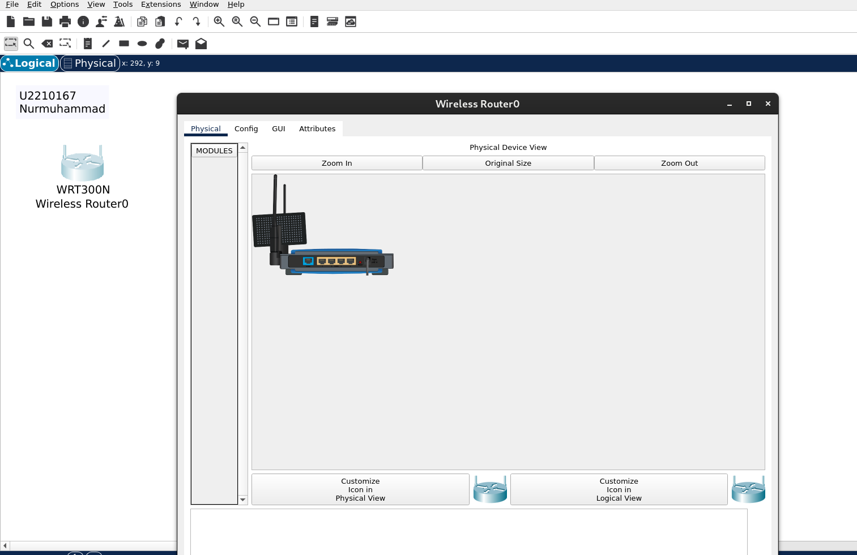

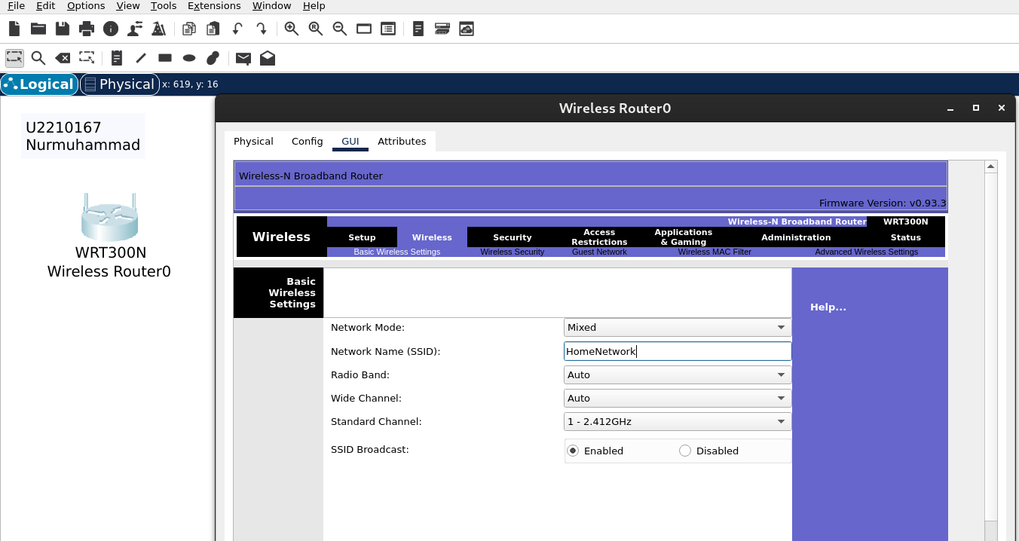

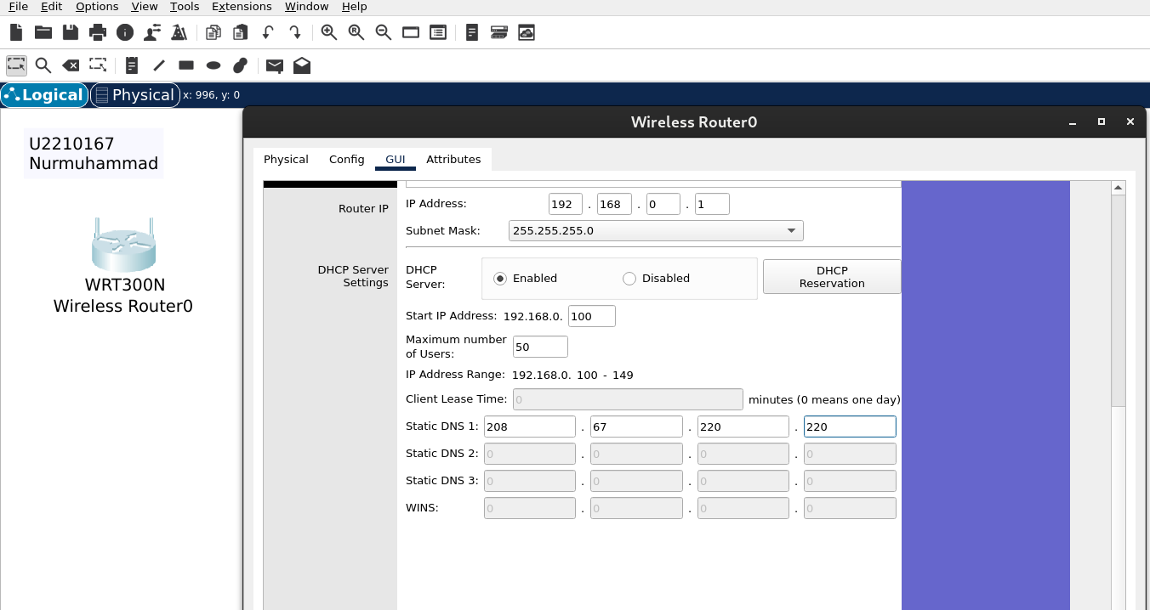

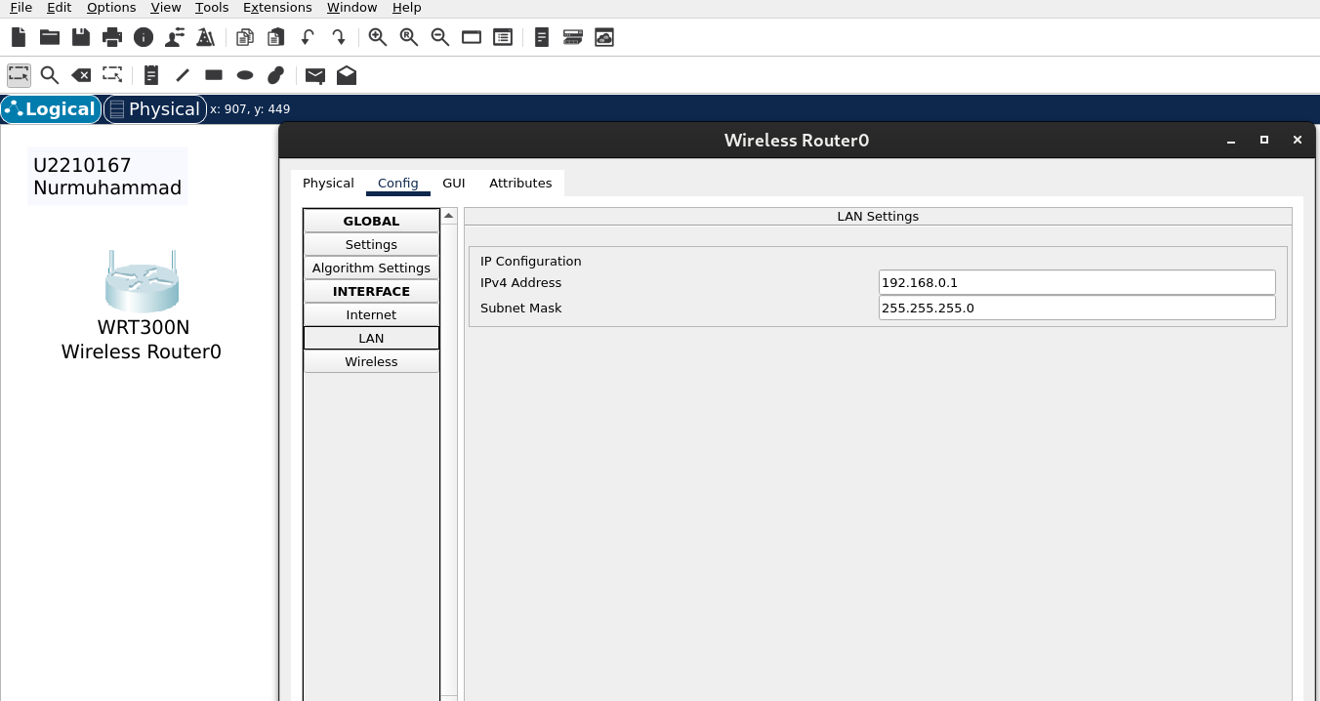

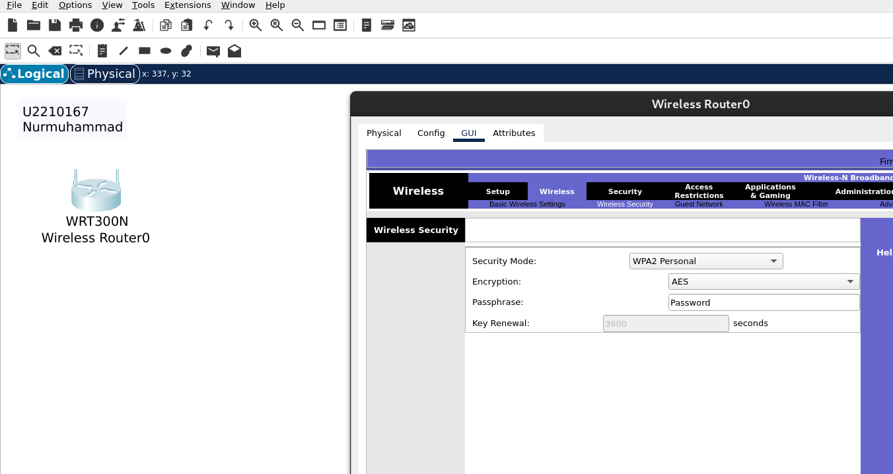

In this step, I configured the wireless router to serve as the central device for wireless and wired communication within the office network.

First, I clicked on the wireless router and opened the **GUI tab**. Under the **Basic Setup**, I changed the router name to **OfficeRouter** for easier identification. I set the **Local IP Address** to **192.168.0.1** and enabled the **DHCP server**, assigning the following parameters:

Start IP Address: 192.168.0.100

Maximum Number of Users: 50

Subnet Mask: 255.255.255.0 (default)

Default Gateway: 192.168.0.1 (automatically filled)

Next, I navigated to the **Wireless > Basic Wireless Settings** tab. I configured the **SSID (network name)** to be **OfficeNet**, kept the **Wireless Network Mode** on **Mixed**, and left the channel on **Auto** for dynamic selection.

After setting up the basic wireless settings, I went to the **Wireless Security** section and set password

**Activity 2**

Configuring WLAN using Packet Tracer

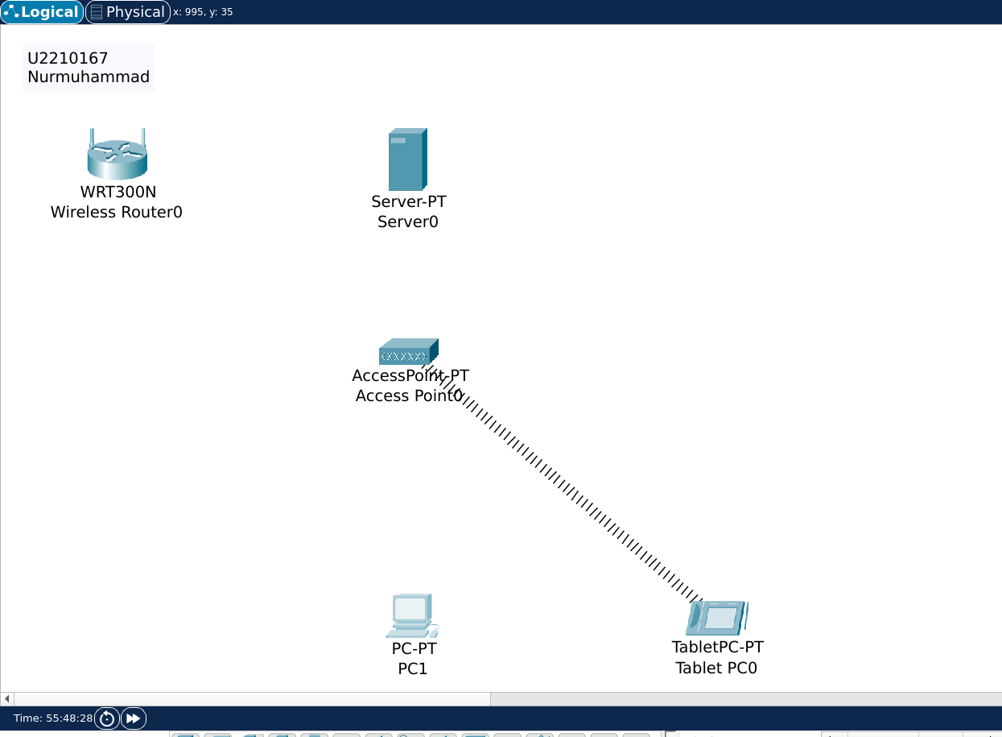

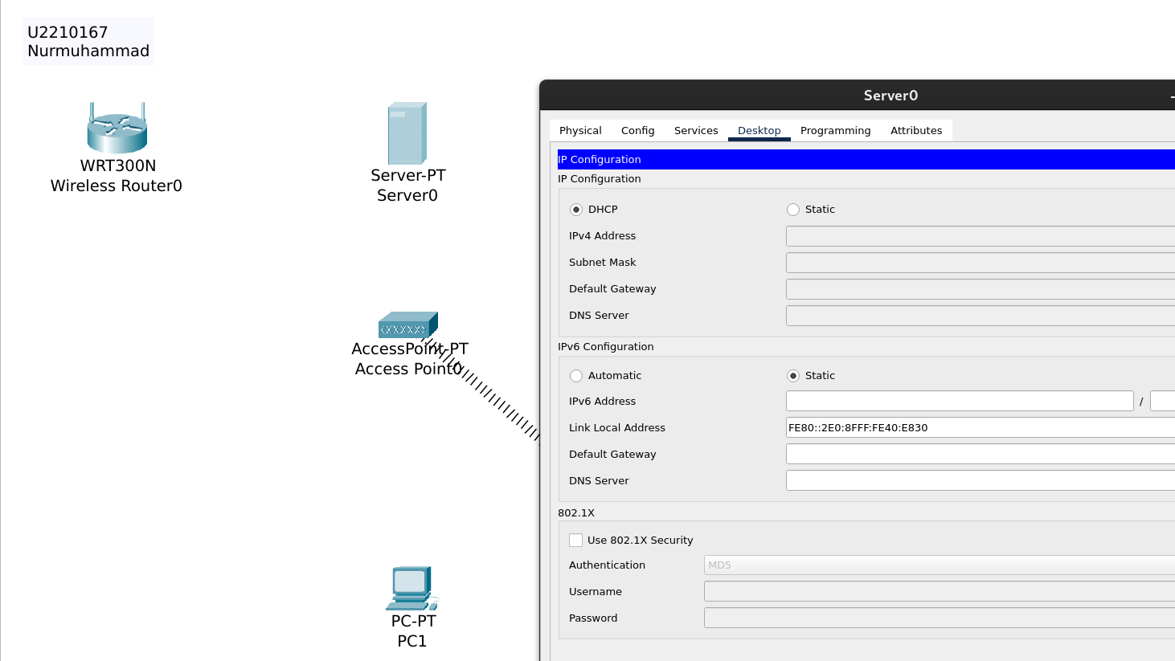

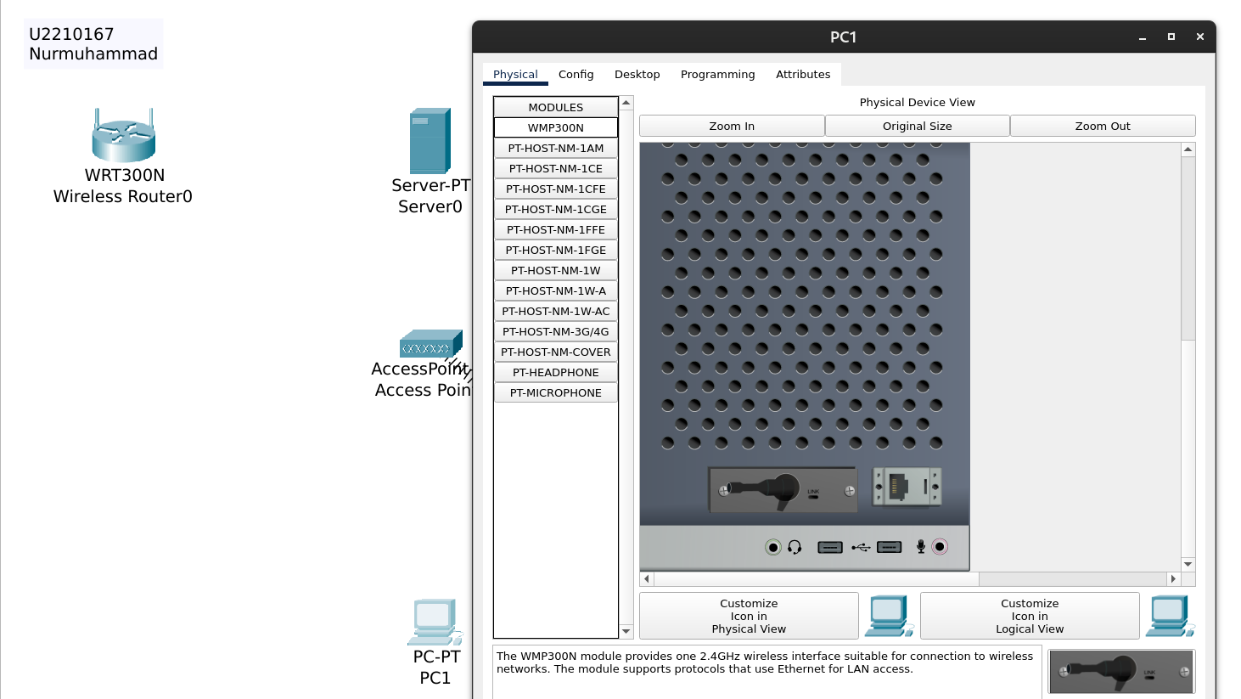

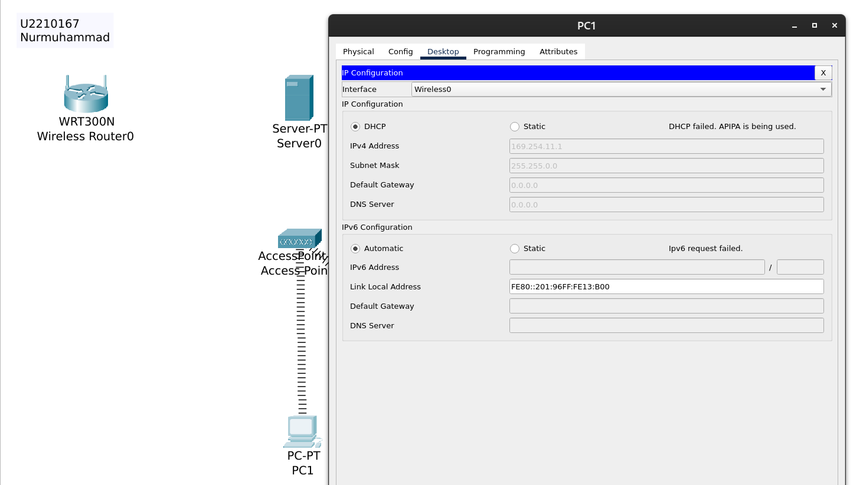

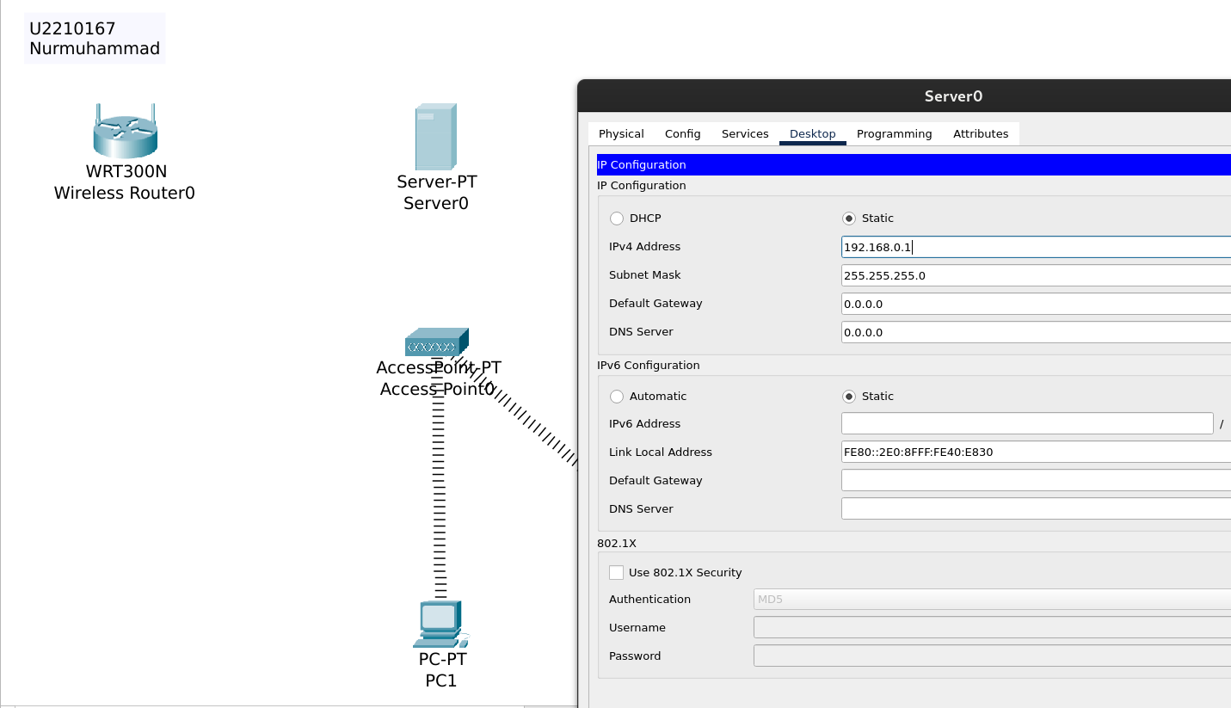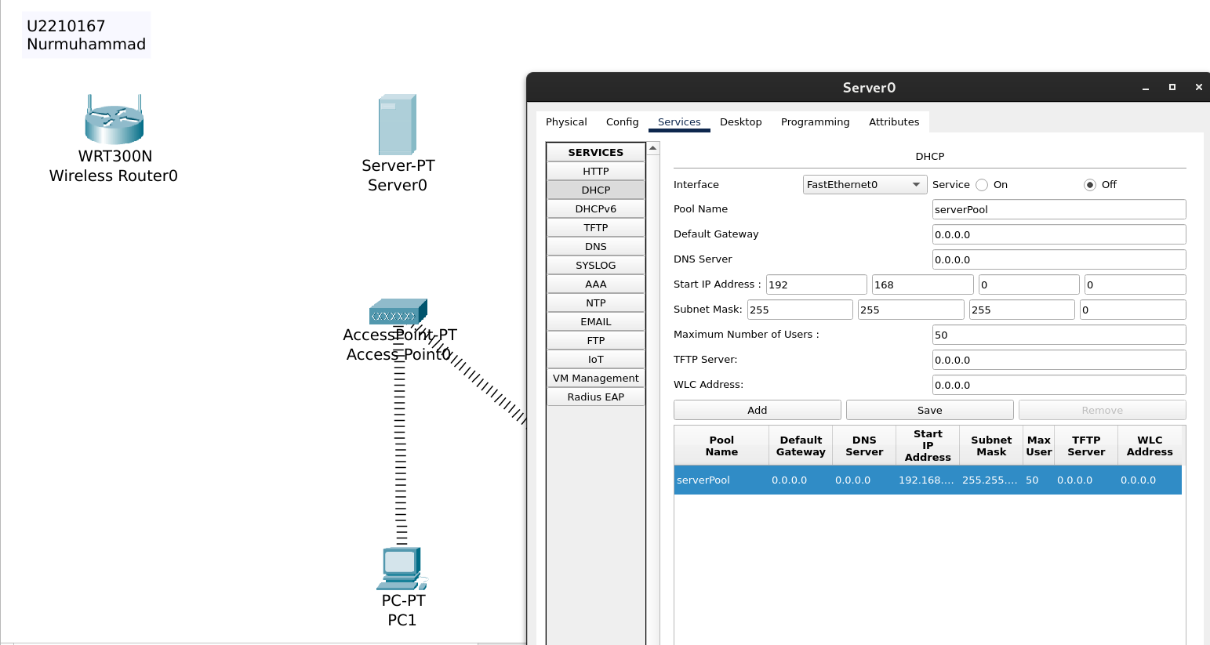

I configured a wireless network using a wireless router and wireless clients in Cisco Packet Tracer.First, I placed a Wireless Router and multiple Wireless PCs (Laptops) in the workspace.I powered on the devices and configured the SSID (network name) on the router under wireless settings.I set a network mode, enabled security (WPA2-PSK), and set a password for the wireless network.Then, I configured each laptop's wireless settings to connect to the correct SSID using the correct password.After connecting, I checked the IP addresses to make sure they were in the correct range assigned by the router.  
Finally, I tested the connection by pinging between devices and the router, confirming successful wireless communication.

**Activity 3**

Configuring DHCP on ROUTER- using Cisco Packet Tracer

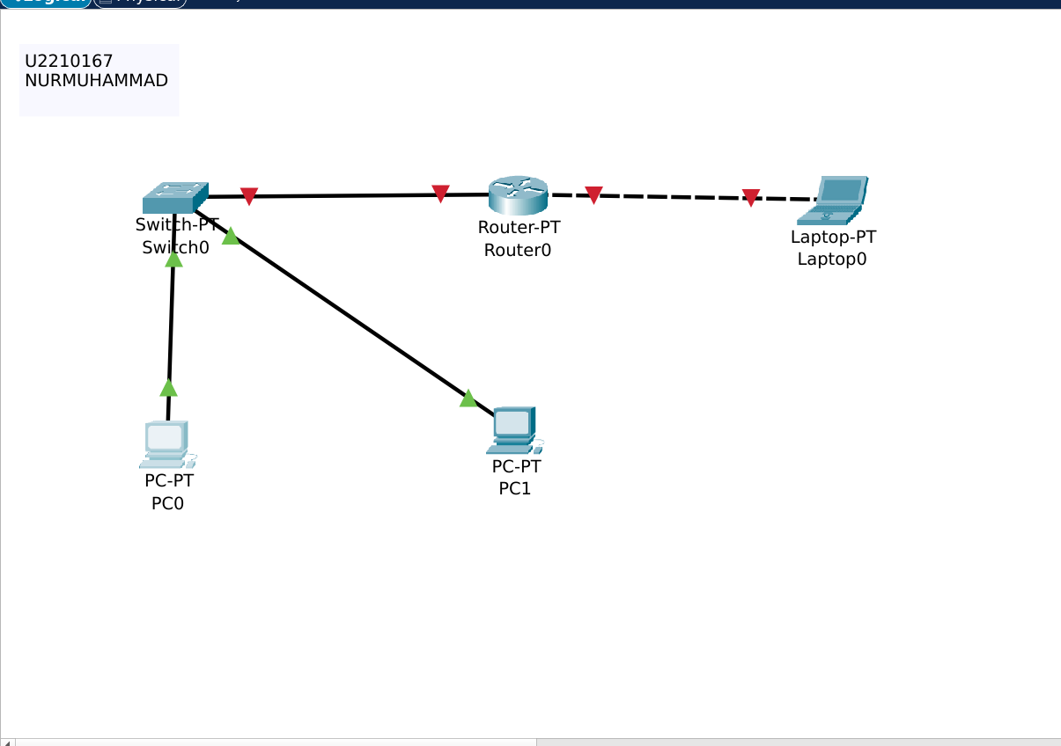

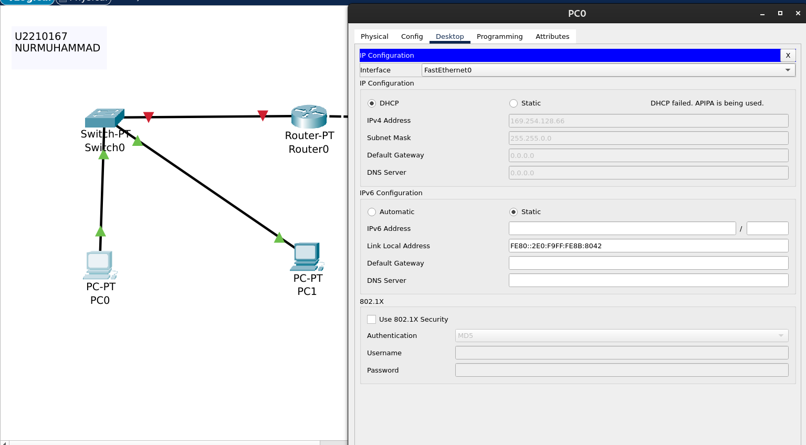

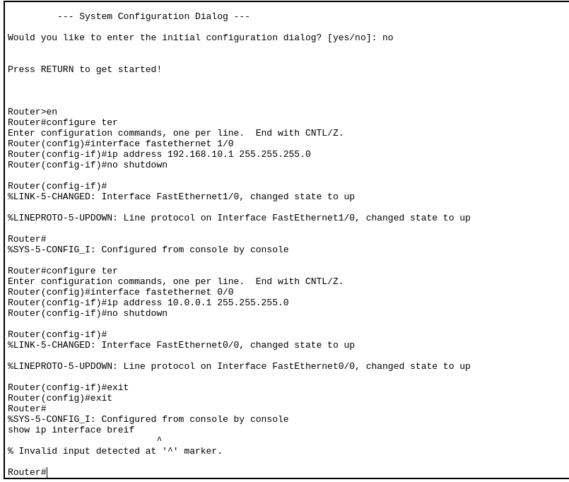

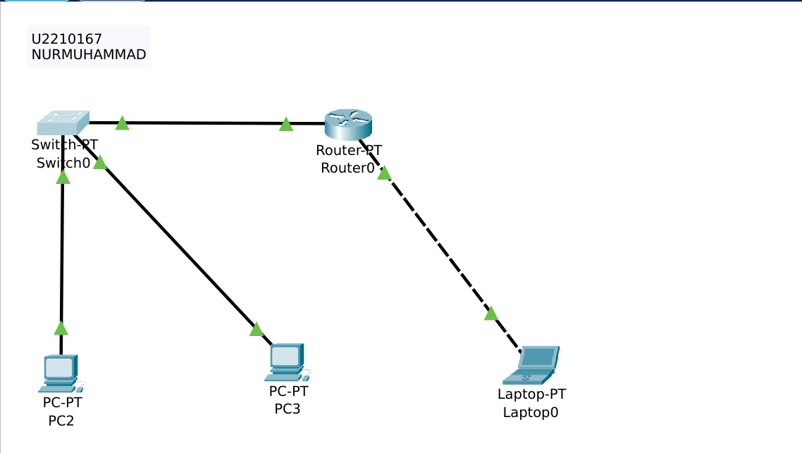

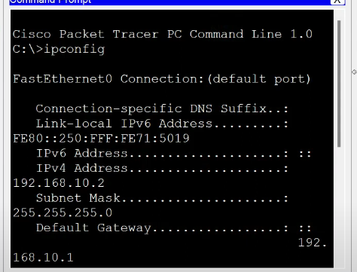

n this lab, I configured a router to provide IP addresses dynamically using DHCP in Cisco Packet Tracer.  
First, I placed a router, a switch, and multiple PCs into the workspace.  
I connected the router to the switch and the PCs to the switch using copper straight-through cables.  
I accessed the router CLI, entered enable mode, and then global configuration mode.  
I configured the router interface connected to the switch with an IP address and subnet mask, and enabled the interface.  
I created a DHCP pool, assigned a network address, default gateway, and DNS server for the DHCP pool.  
I excluded a range of IP addresses from being assigned automatically to devices.  
On each PC, I set the network configuration to DHCP mode to obtain an IP address automatically.  
I verified that the PCs received the correct IP addresses from the router within the expected range.  
Finally, I tested connectivity by pinging the router from the PCs, and the pings were successful.

窗体底端

**Activity 4**

Configuring DHCP Server- using Cisco Packet Tracer

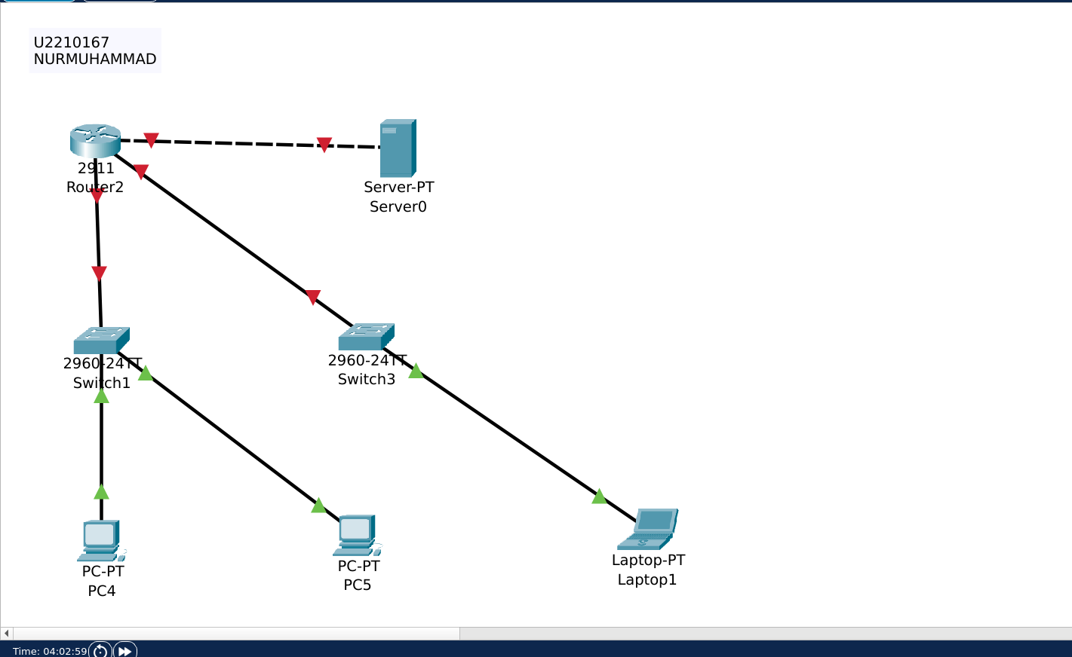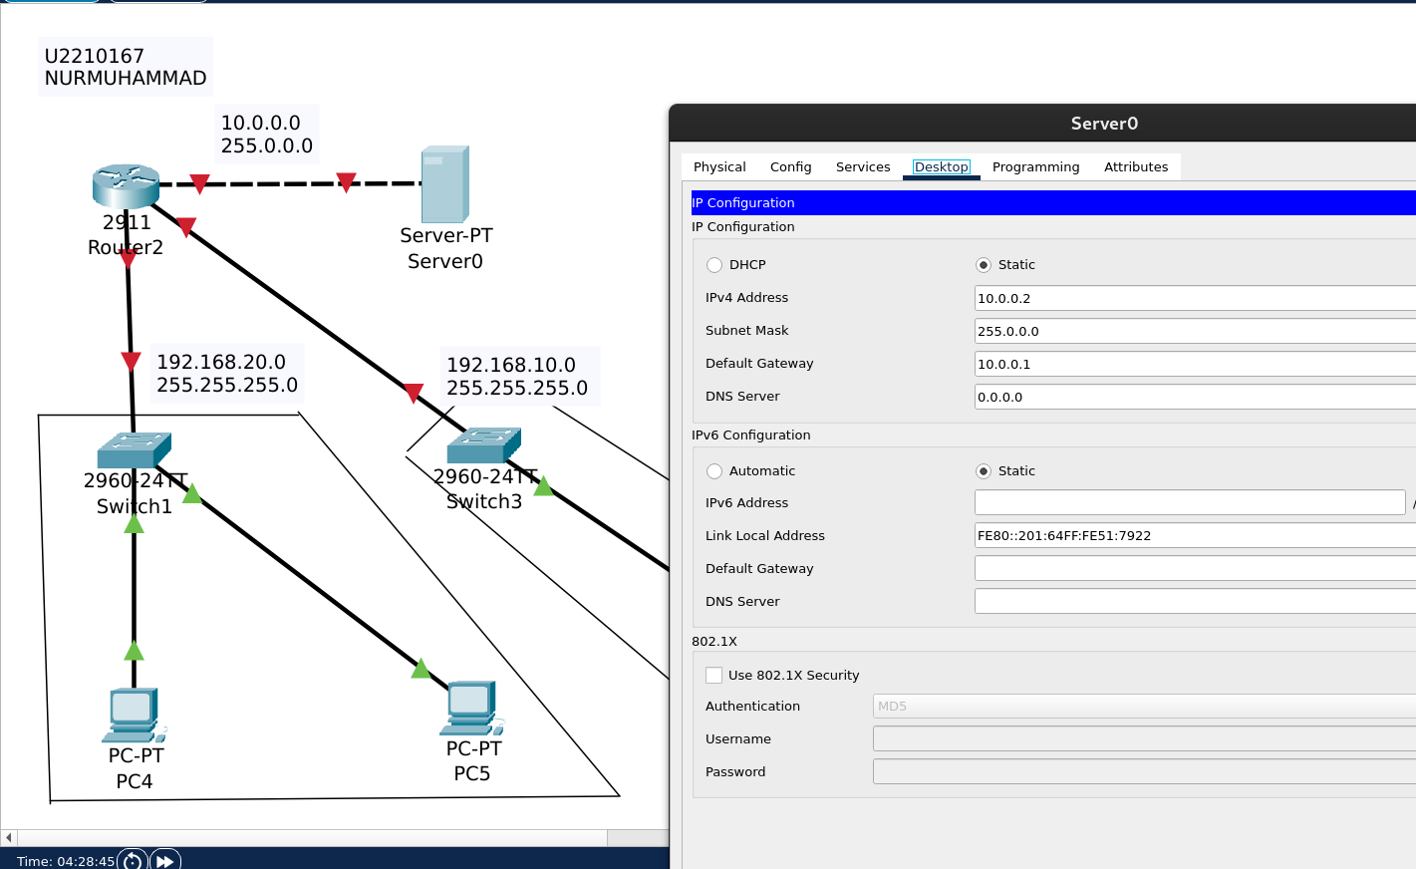

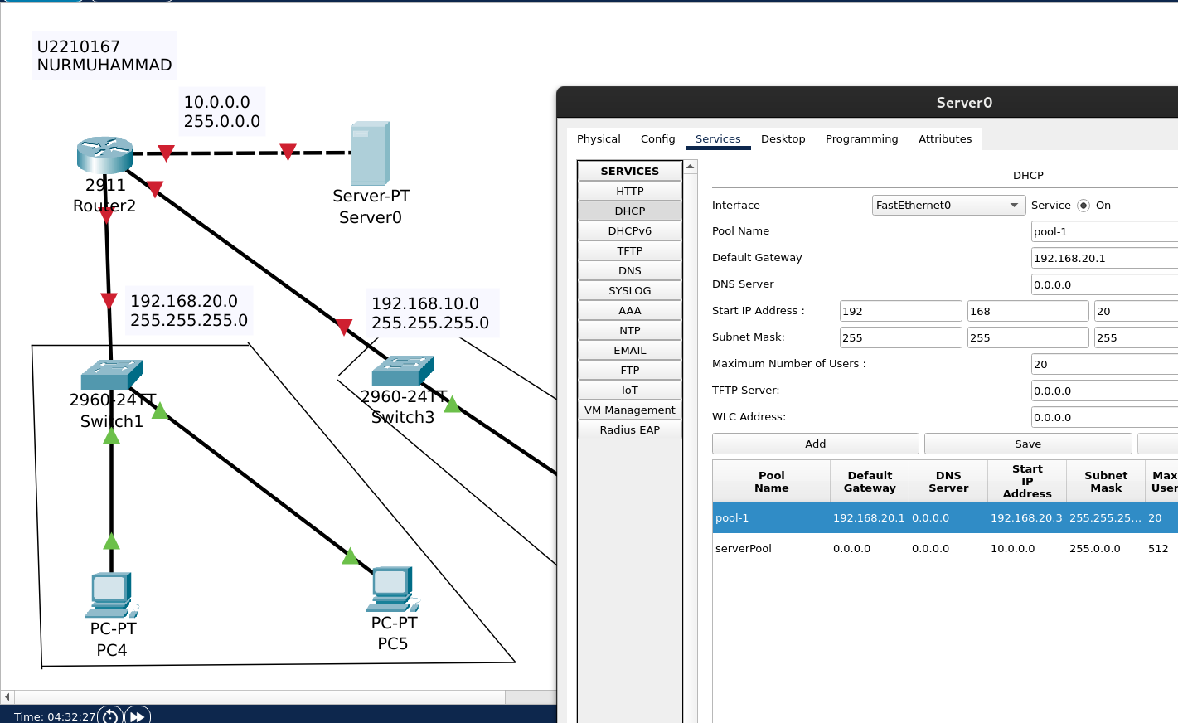

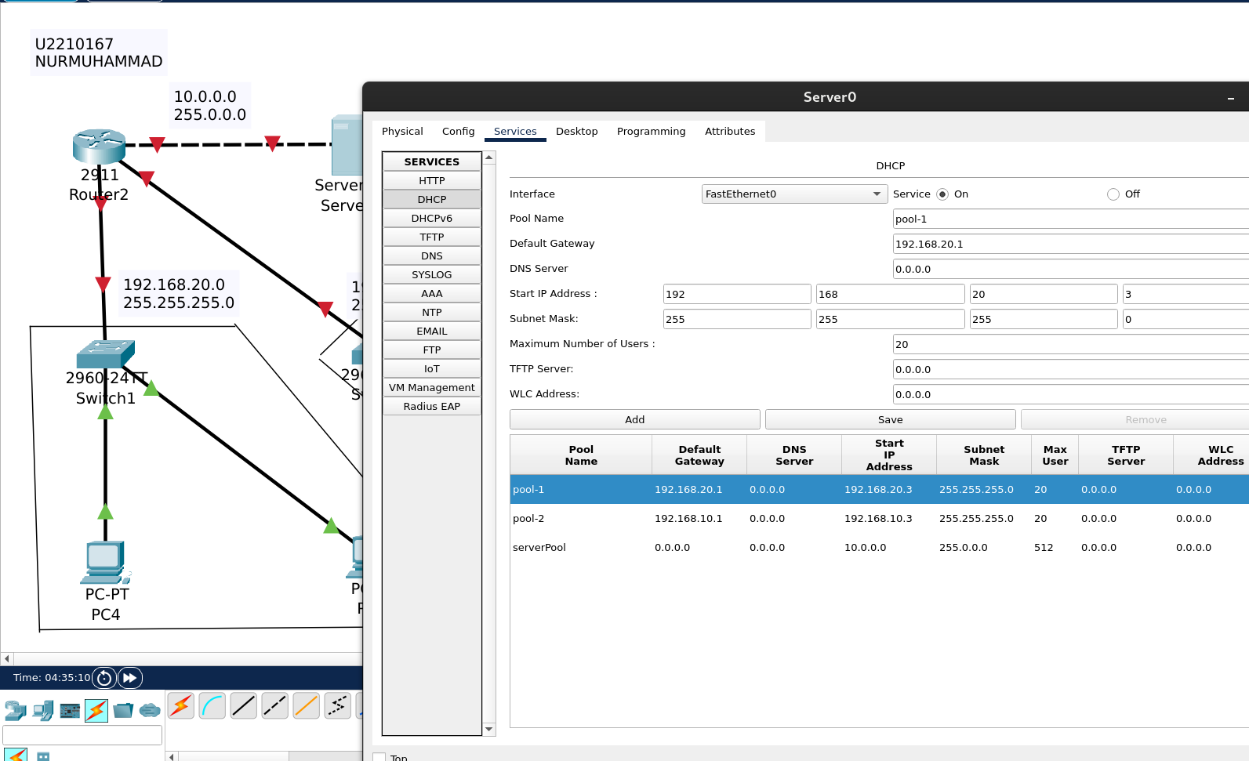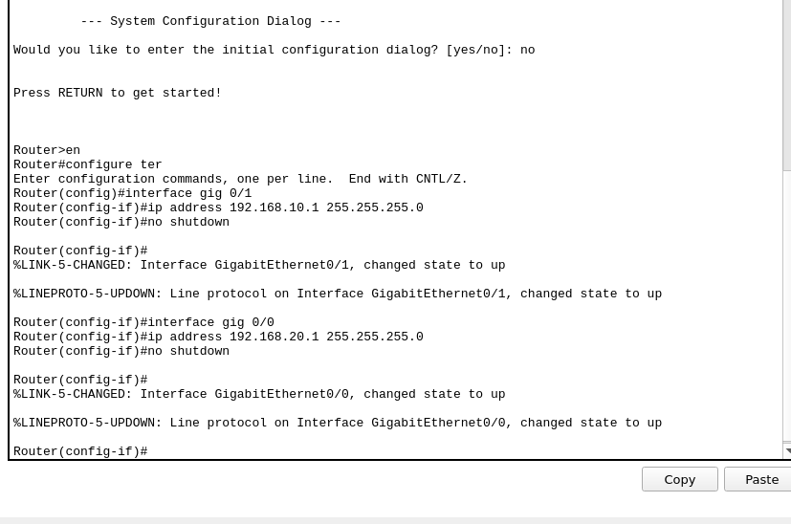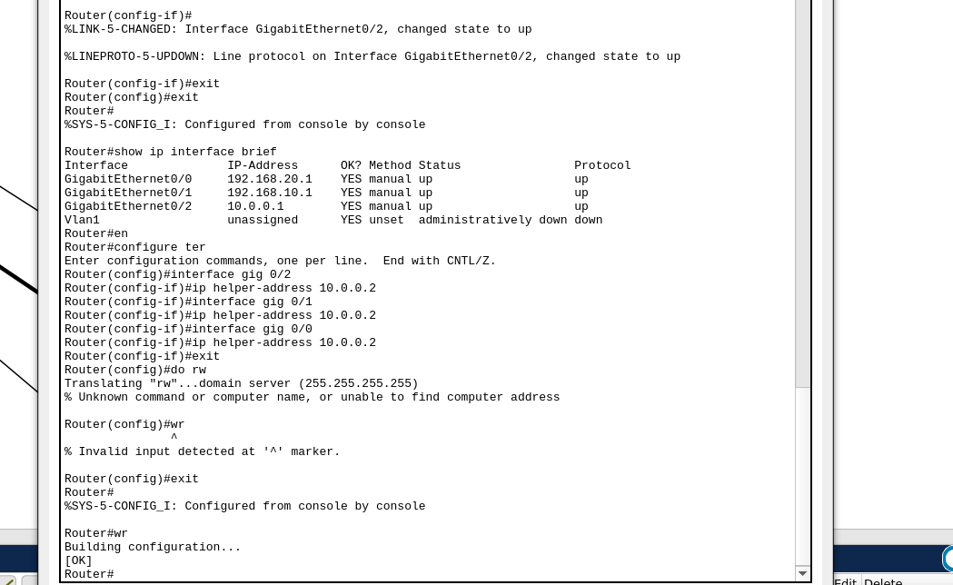

I configured a DHCP Server to automatically assign IP addresses to devices in Cisco Packet Tracer.  
First, I placed a DHCP Server, a Switch, and multiple PCs in the workspace.  
I connected the DHCP Server and the PCs to the Switch using copper straight-through cables.  
I powered on all devices and configured the Server with a static IP address.  
I entered the Server's DHCP service settings and created a new DHCP pool by specifying the network address, subnet mask, default gateway, and DNS server.  
I activated the DHCP service on the Server.  
On each PC, I set the network configuration to DHCP mode to obtain an IP address automatically.  
I checked that the PCs successfully received IP addresses from the DHCP Server within the correct range.  
Finally, I verified the connectivity by pinging between PCs and the Server, and the pings were successful.  
Through this lab, I learned how to configure and verify a DHCP Server setup in a simple network environment.

**Activity 5**

Simulate FTP Server using Cisco packet Tracer

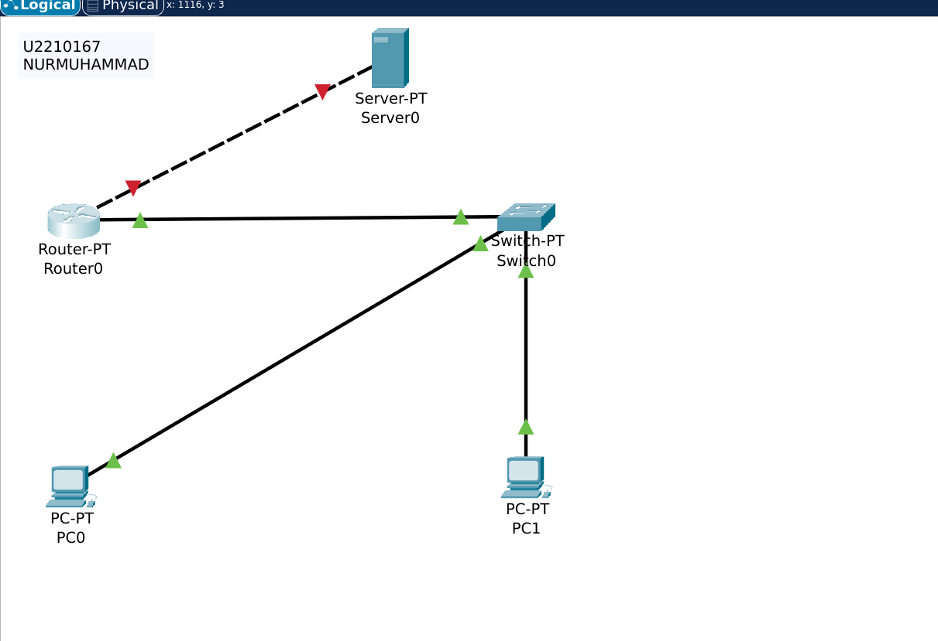

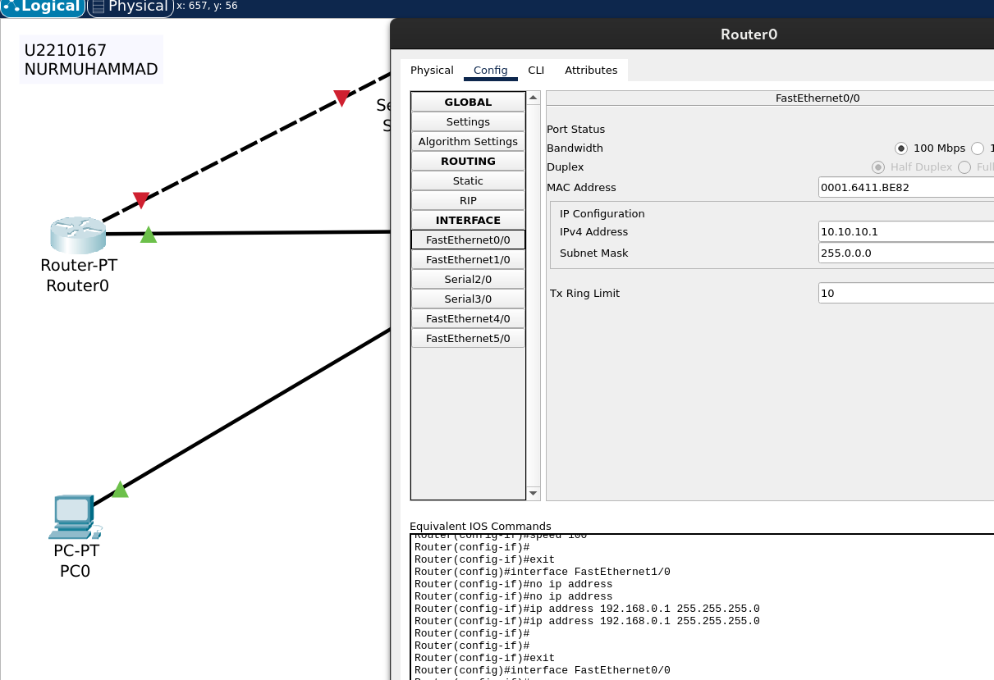

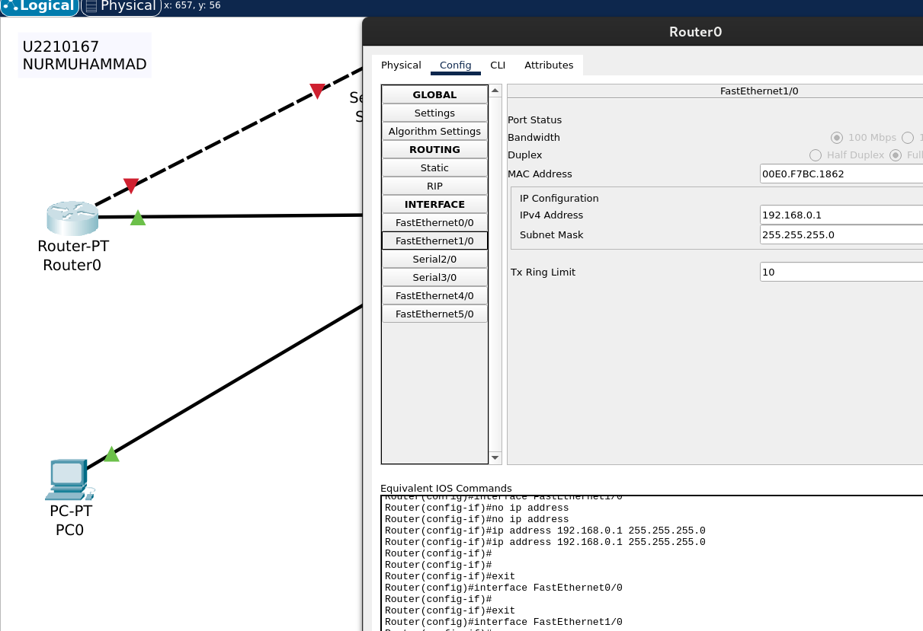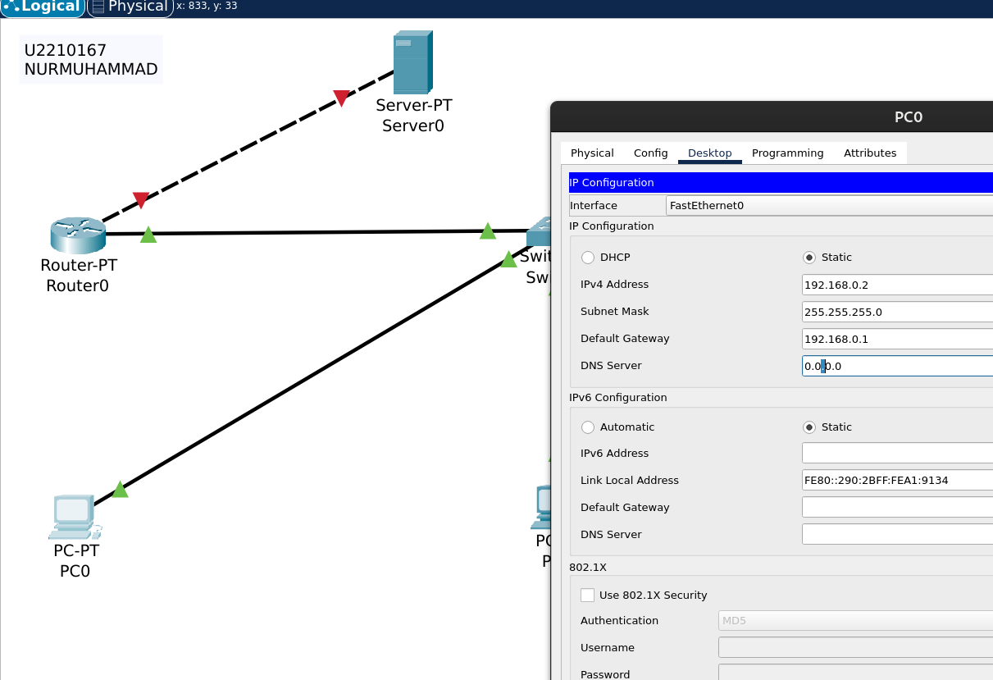

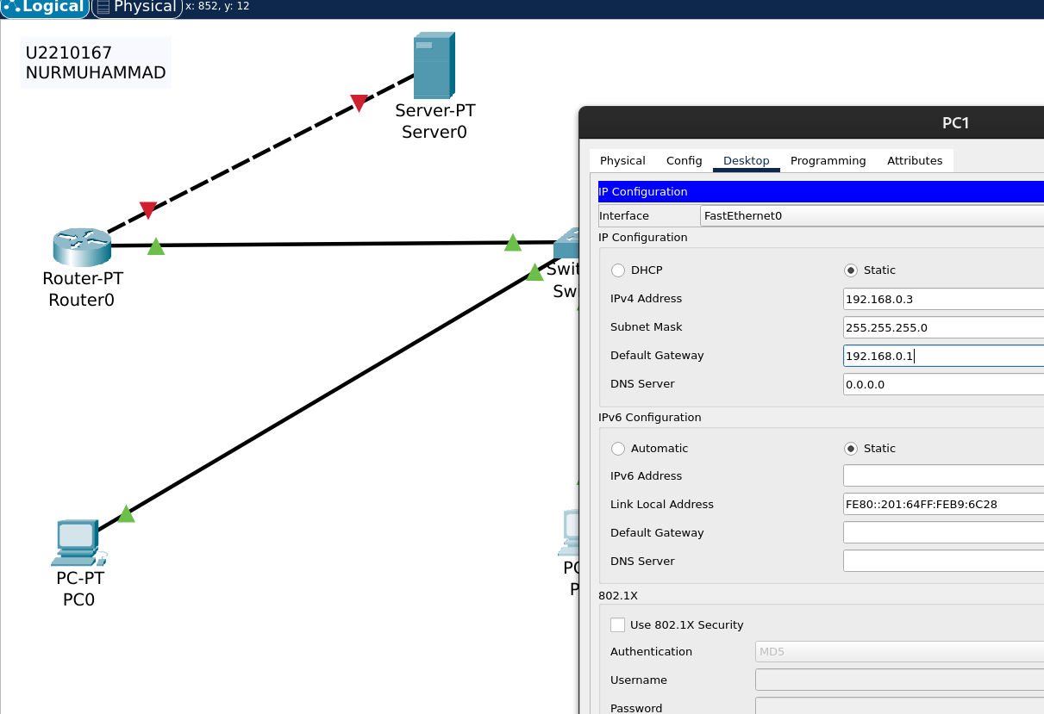

\

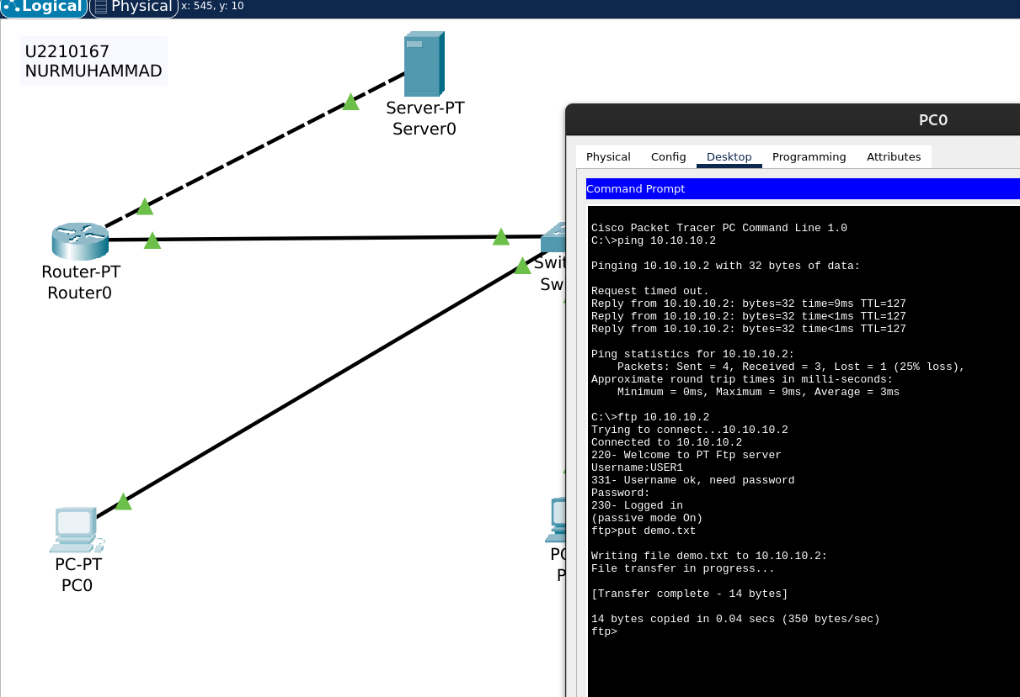

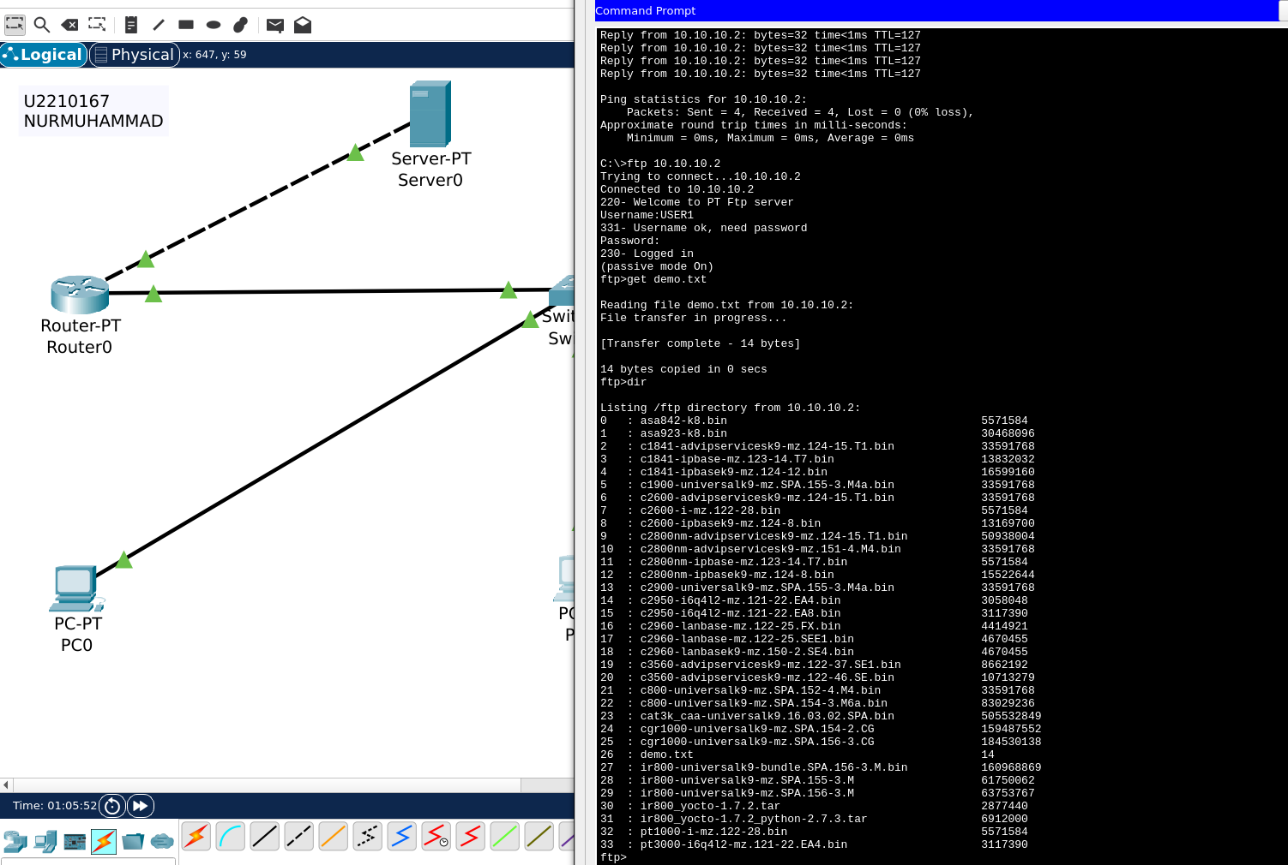

I simulated an FTP Server using Cisco Packet Tracer.  
First, I placed a Server, a Switch, and multiple PCs in the workspace.  
I connected the Server and PCs to the Switch using copper straight-through cables.  
I configured a static IP address on the Server and enabled the FTP service on it.  
I created user accounts with usernames and passwords on the Server under the FTP settings.  
Each PC was configured with an IP address in the same network as the Server.  
I used the PC’s command prompt to connect to the FTP Server using the ftp command followed by the Server’s IP address.  
I logged in with the correct username and password and tested uploading and downloading files.  
I verified that file transfers were successful, confirming that the FTP Server simulation worked properly.  
Through this lab, I learned how to set up an FTP service and use FTP commands to transfer files in a simulated network environment.

**Activity 6**

HTTP - webserver configuration using Packet Tracer

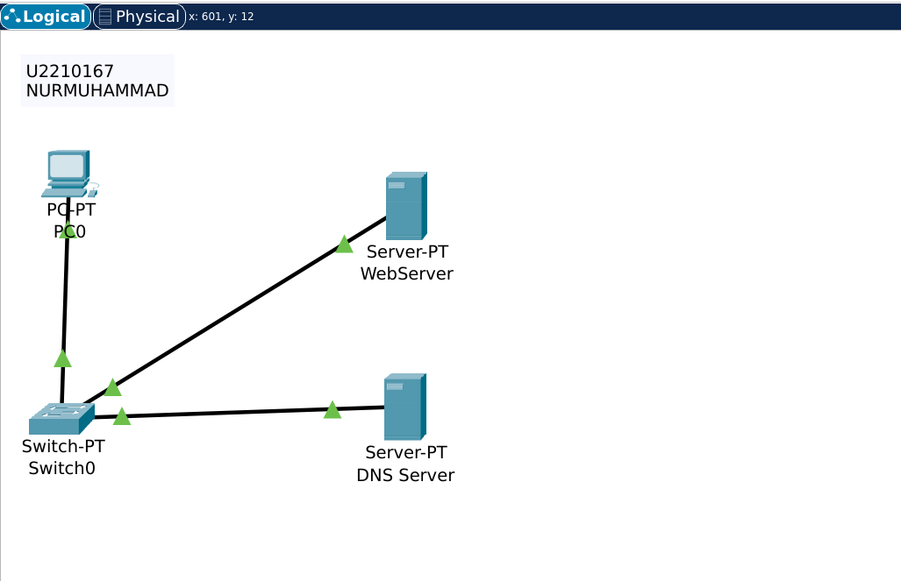

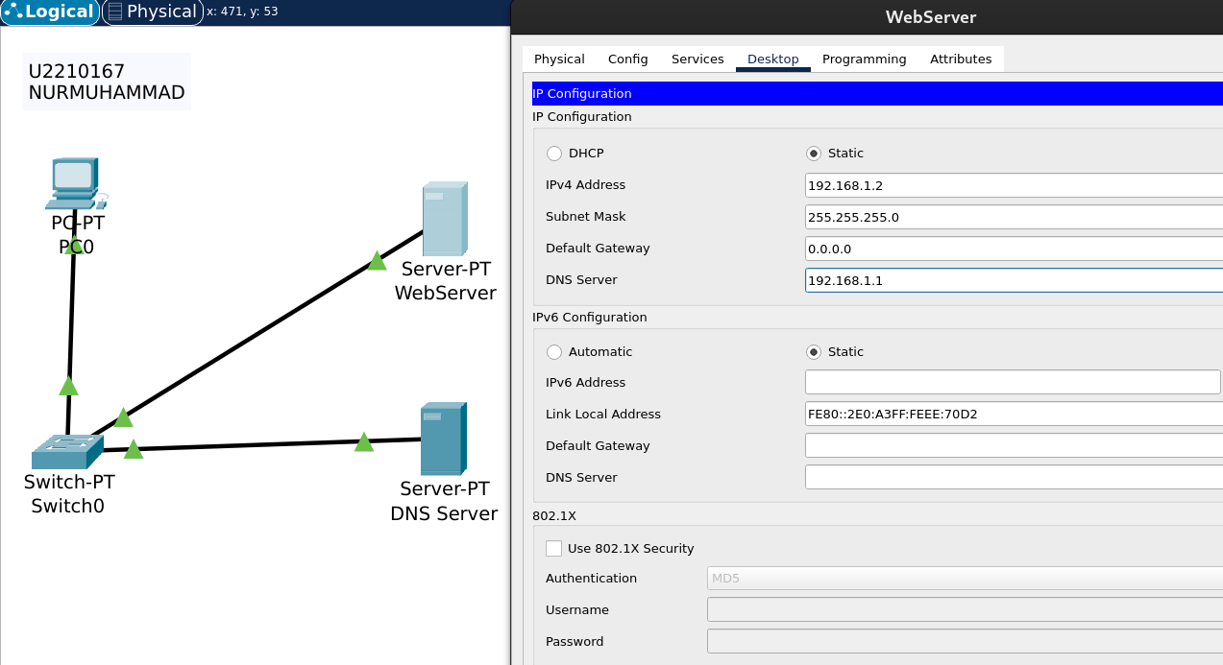

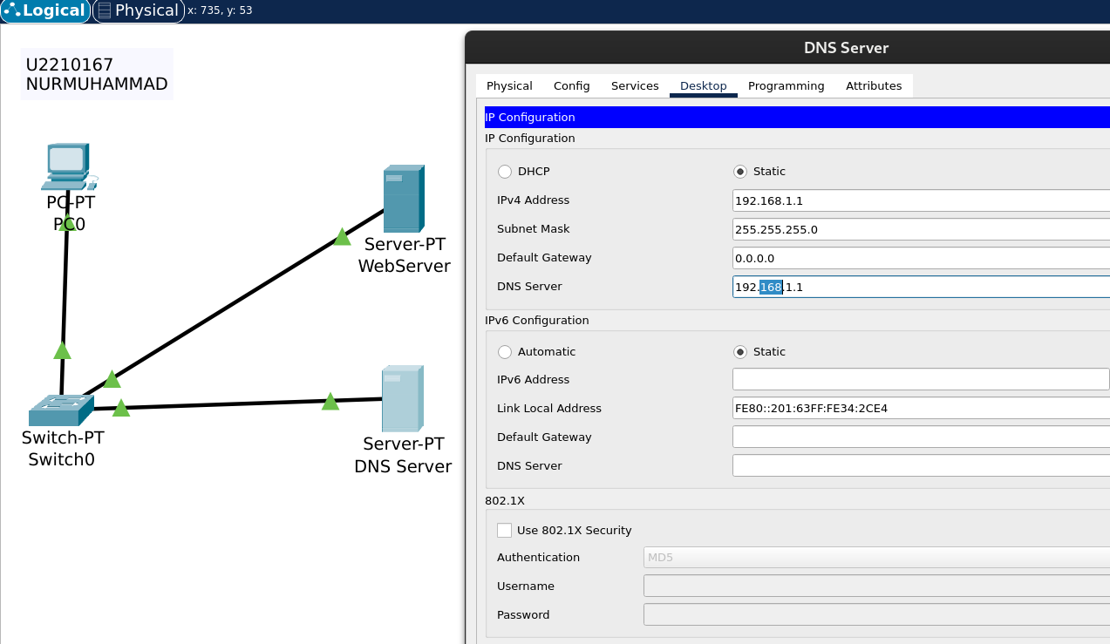

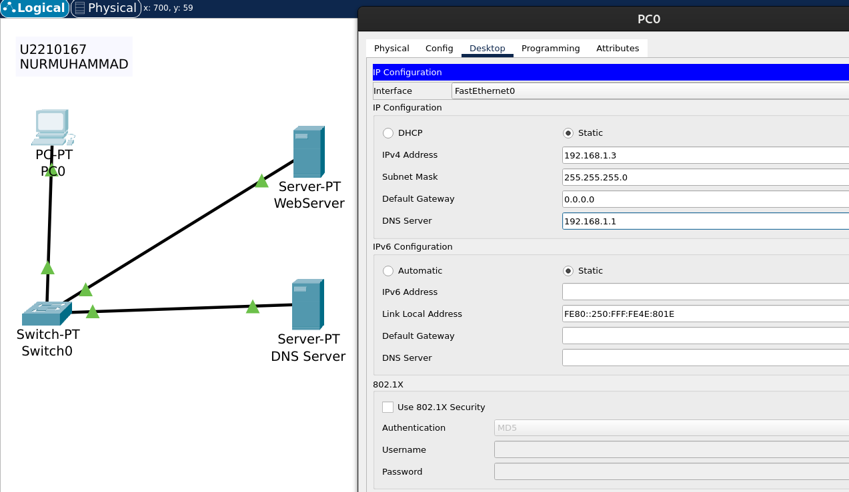

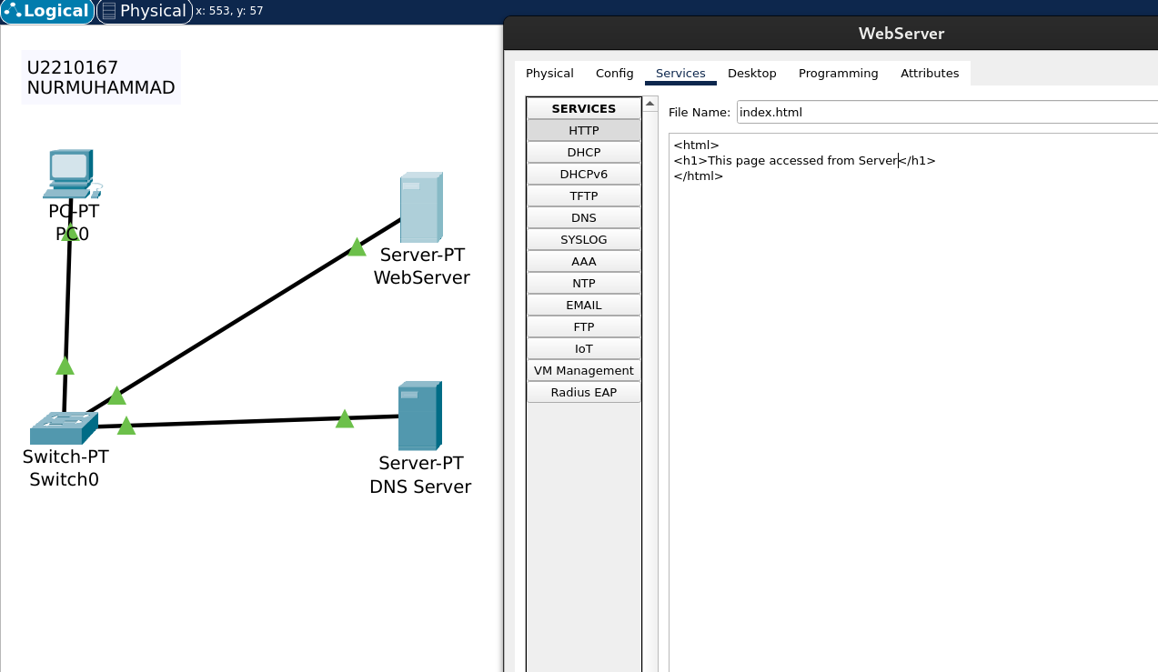

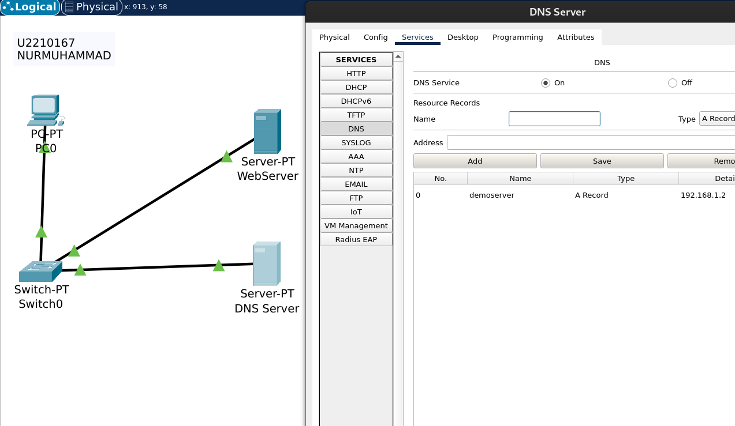

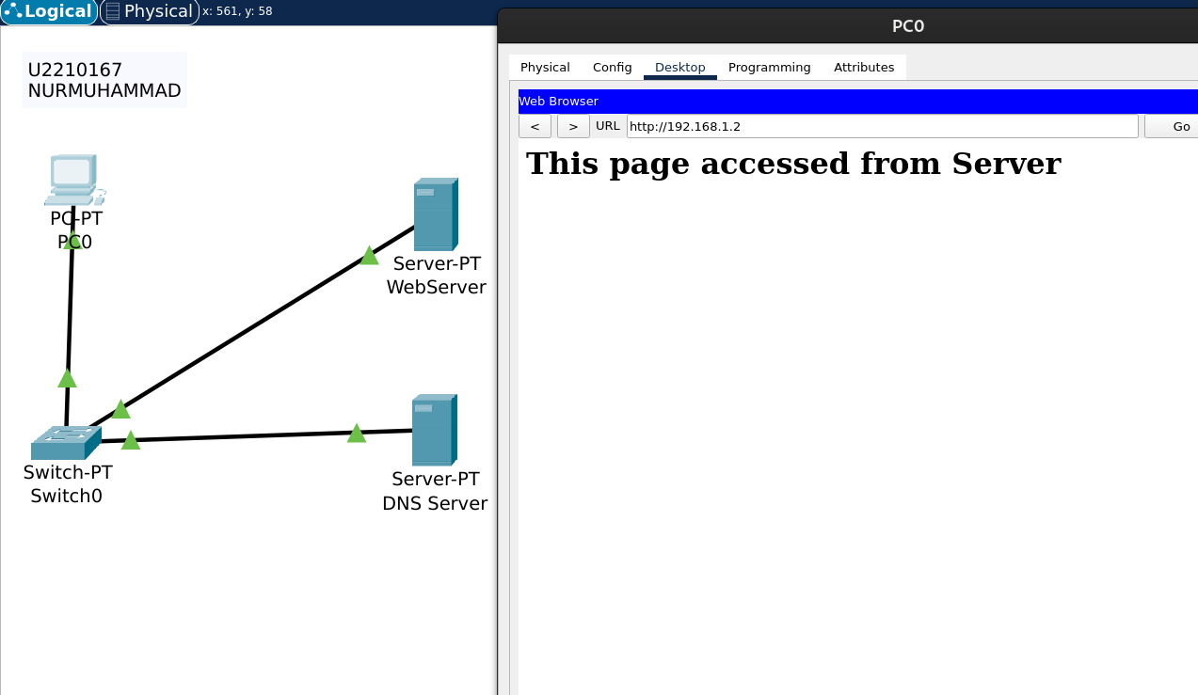

I configured a Web Server using Cisco Packet Tracer to simulate HTTP communication.  
I placed a Web Server, a DNS Server, a Switch, and a PC (PC0) into the workspace and connected them using copper straight-through cables.  
I assigned static IP addresses to the Web Server, DNS Server, and PC, ensuring they were in the same subnet.  
On the Web Server, I enabled the HTTP service and edited the default web page content to display a custom message.  
On the DNS Server, I enabled DNS and added a DNS record pointing the domain name demoserver to the IP address of the Web Server.  
I configured PC0 to use the DNS Server’s IP address for name resolution.  
To test the setup, I opened the web browser on PC0 and entered http://demoserver into the address bar.  
The browser successfully displayed the custom web page from the Web Server, confirming that both HTTP and DNS configurations were working correctly.  
This lab helped me understand how to configure and test basic web and DNS services in a simulated network environment.

**Activity 7**

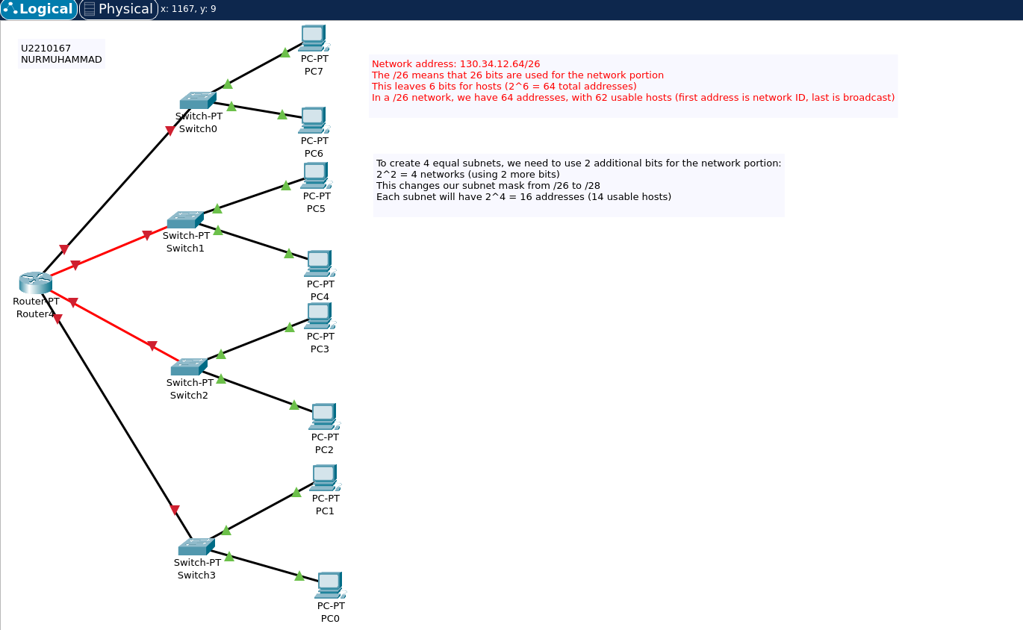

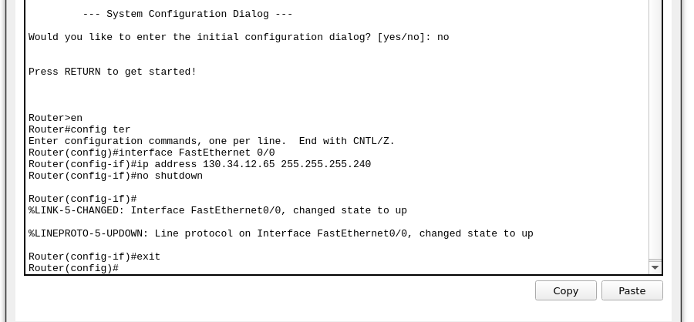

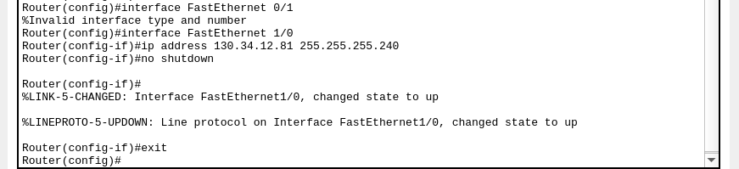

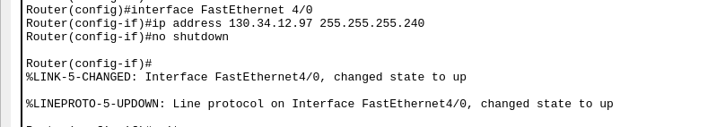

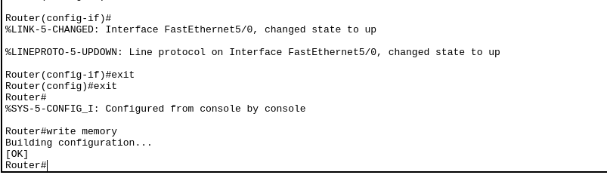

I designed and configured a subnetted network using Cisco Packet Tracer. The organization was allocated the IP block 130.34.12.64/26, which contains 64 IP addresses. My task was to divide this block into four equal subnets, assign IP addresses, and set up network devices including a router, switches, PCs, and a Web Server. I first calculated the subnetting: using a /28 mask, I divided the block into four subnets, each with 16 IP addresses (14 usable). The subnets were: 130.34.12.64/28, 130.34.12.80/28, 130.34.12.96/28, and 130.34.12.112/28. I then placed one router, four switches, eight PCs (two per subnet), and one Web Server in the workspace and connected them using copper straight-through cables. I configured static IP addresses for each device based on their subnet. For each router interface, I used the CLI to enter configuration mode, assign the correct IP address using the ip address command, and enabled the interface using no shutdown. I also enabled the HTTP service on the Web Server. After setting up everything, I tested the network by pinging between devices in different subnets and accessing the web server from a PC browser using its IP address. The web page loaded successfully, confirming that the network was functioning correctly. Through this lab, I learned how to subnet a given IP block, configure devices with static IPs, enable communication across subnets using a router, and simulate an HTTP web server. This practical experience gave me a better understanding of how subnetting and routing work in a real-world scenario.

**Activity 8**

Demonstrate the Distance Vector Routing using RIP Protocol

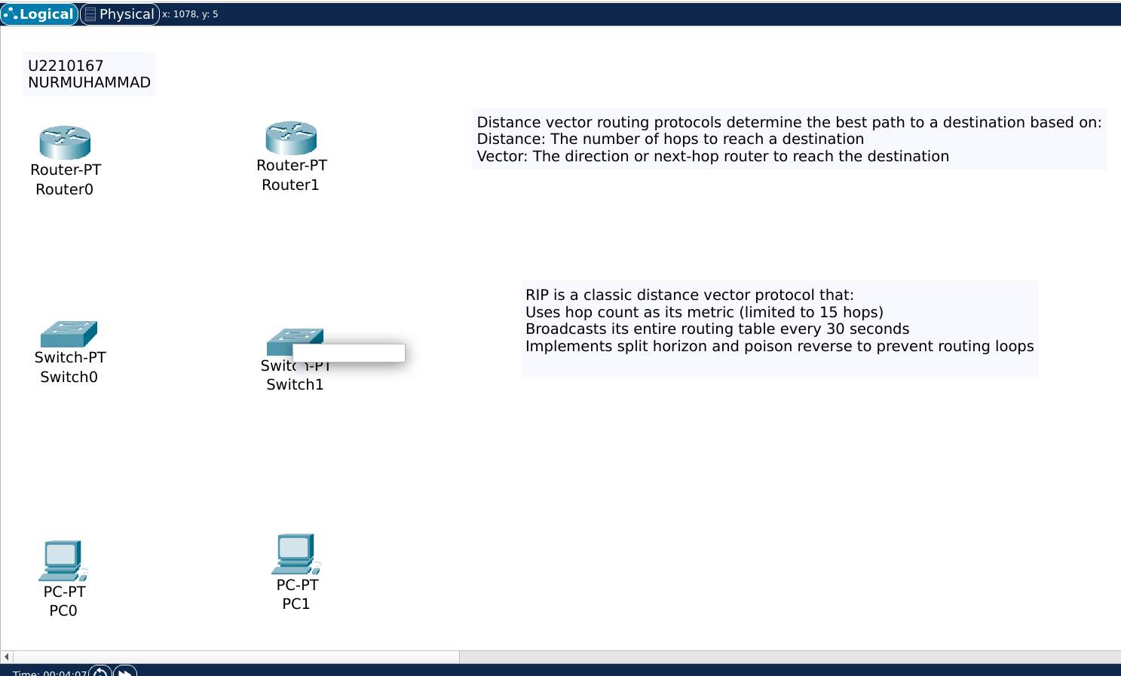

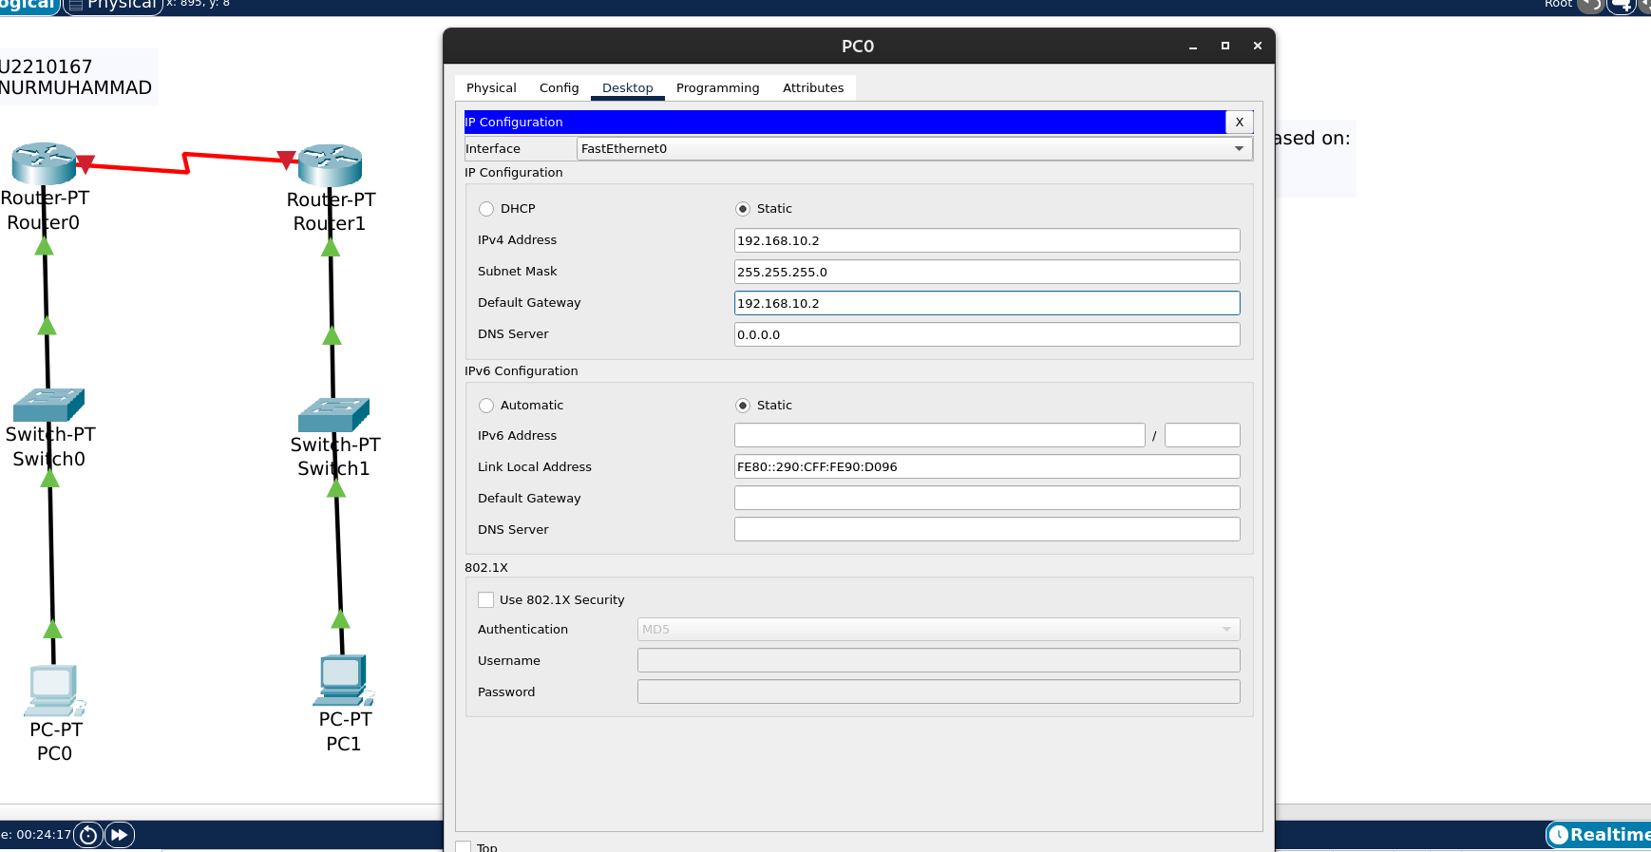

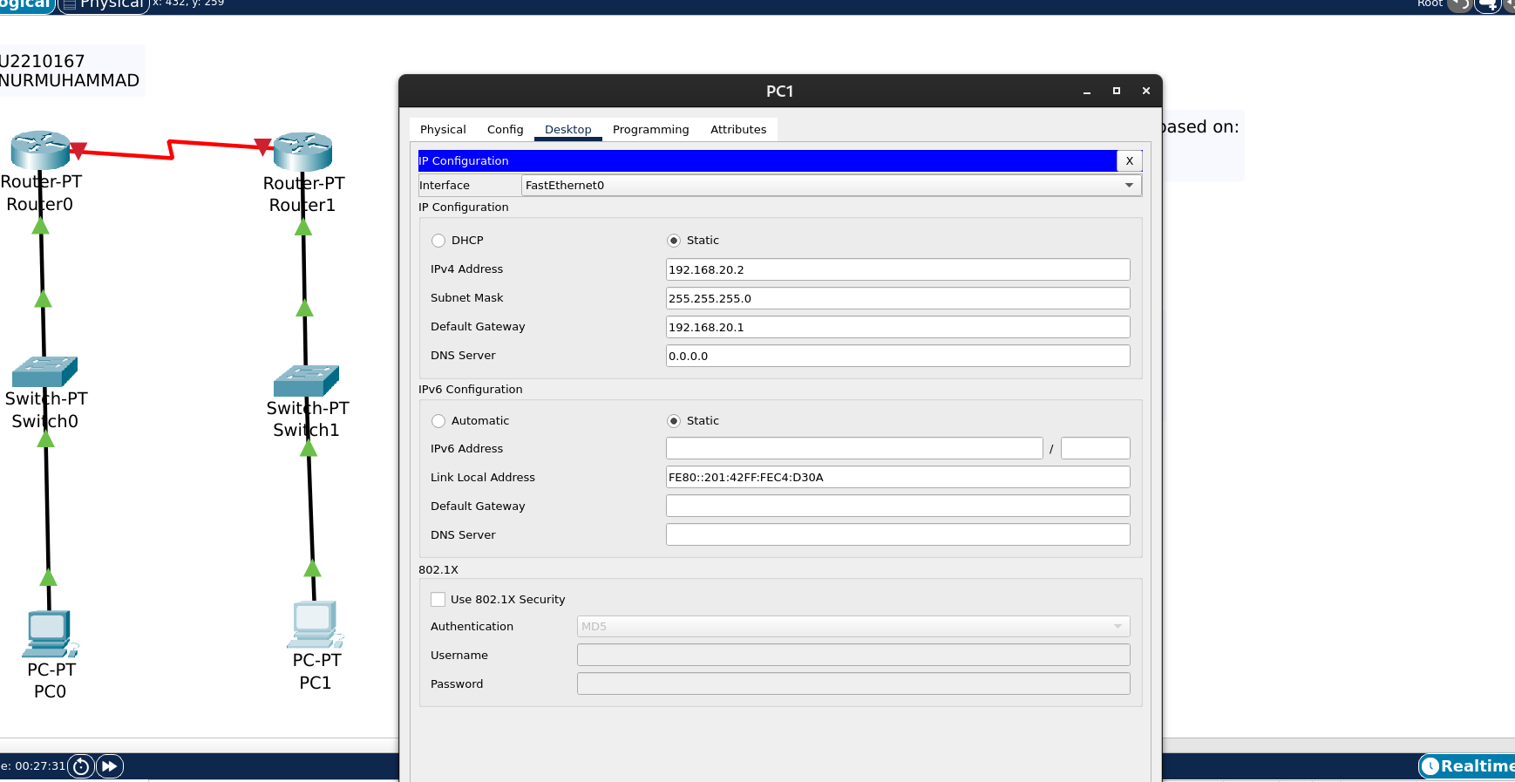

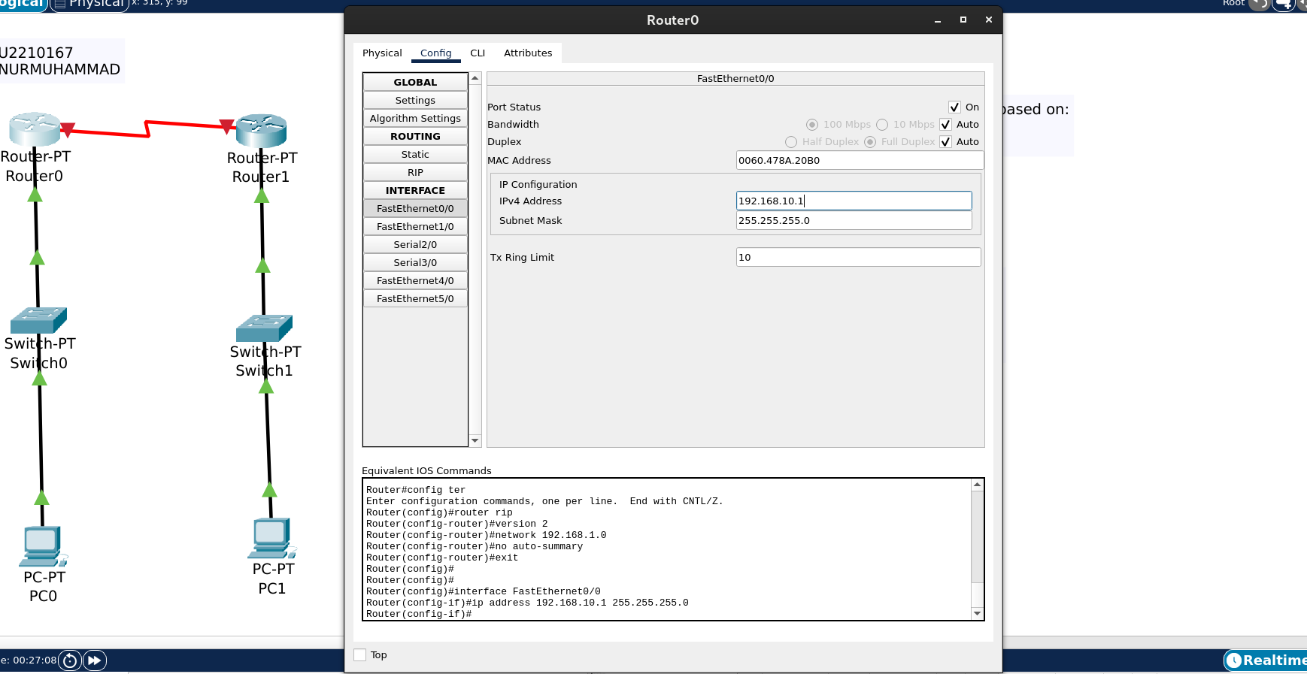

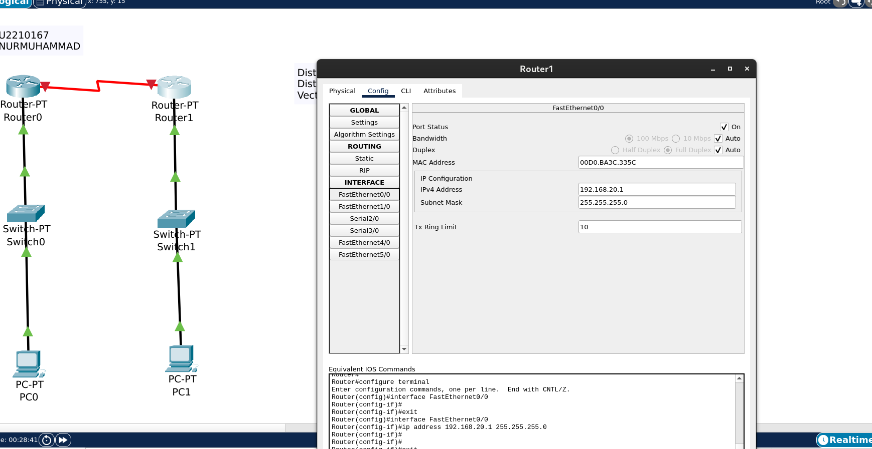

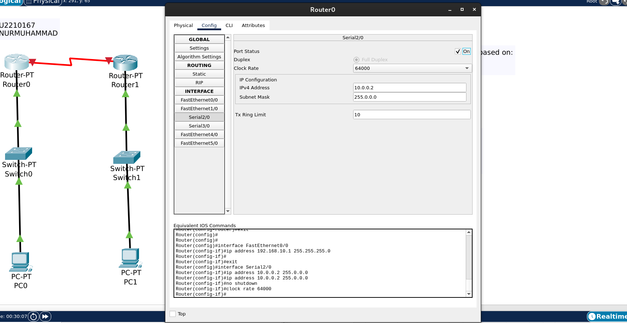

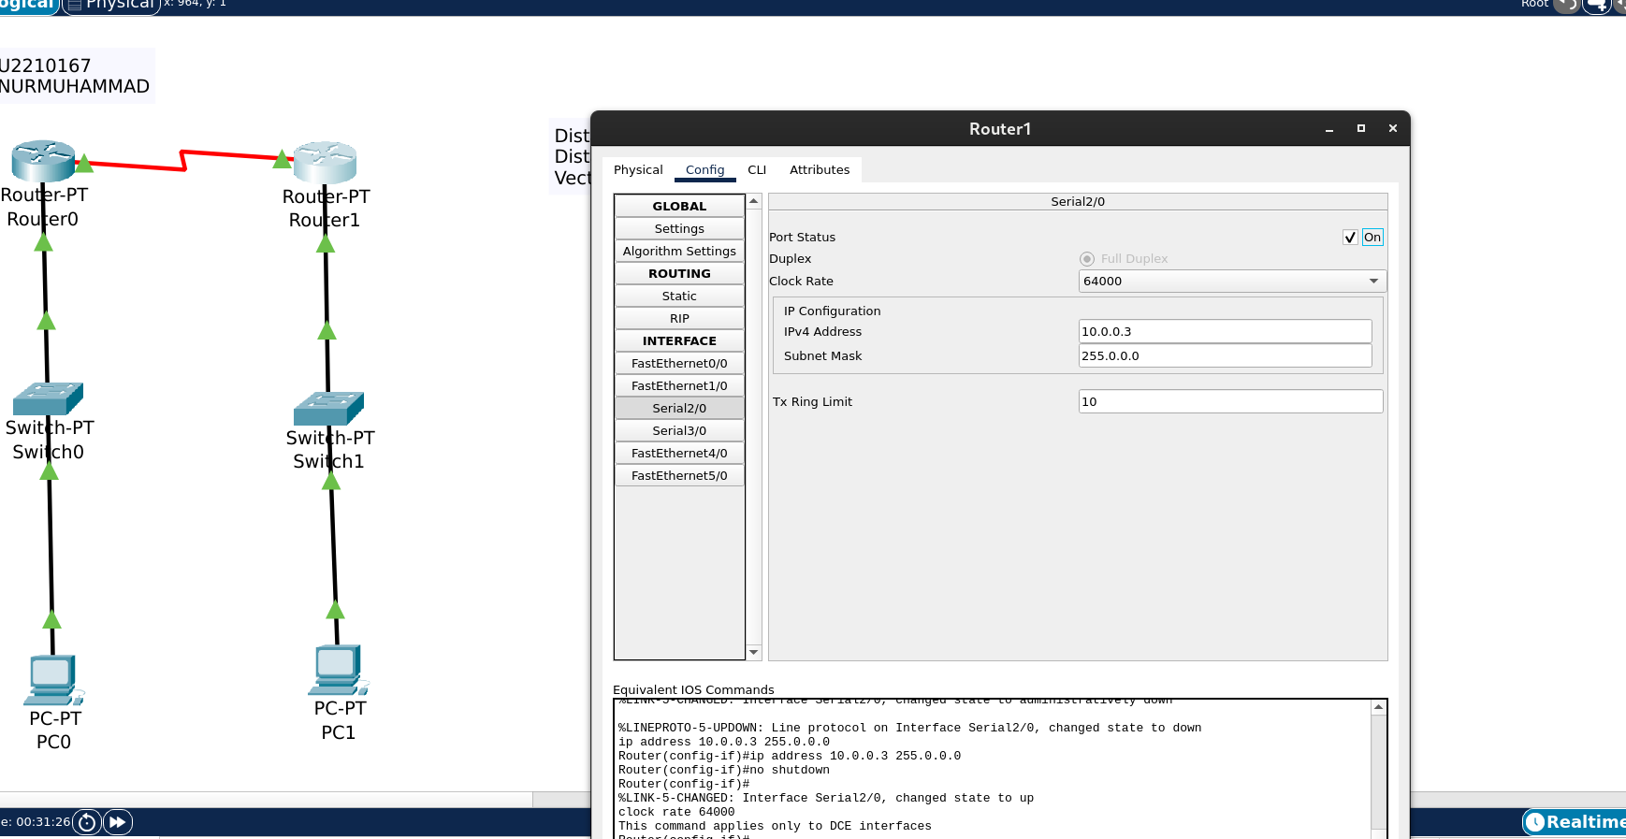

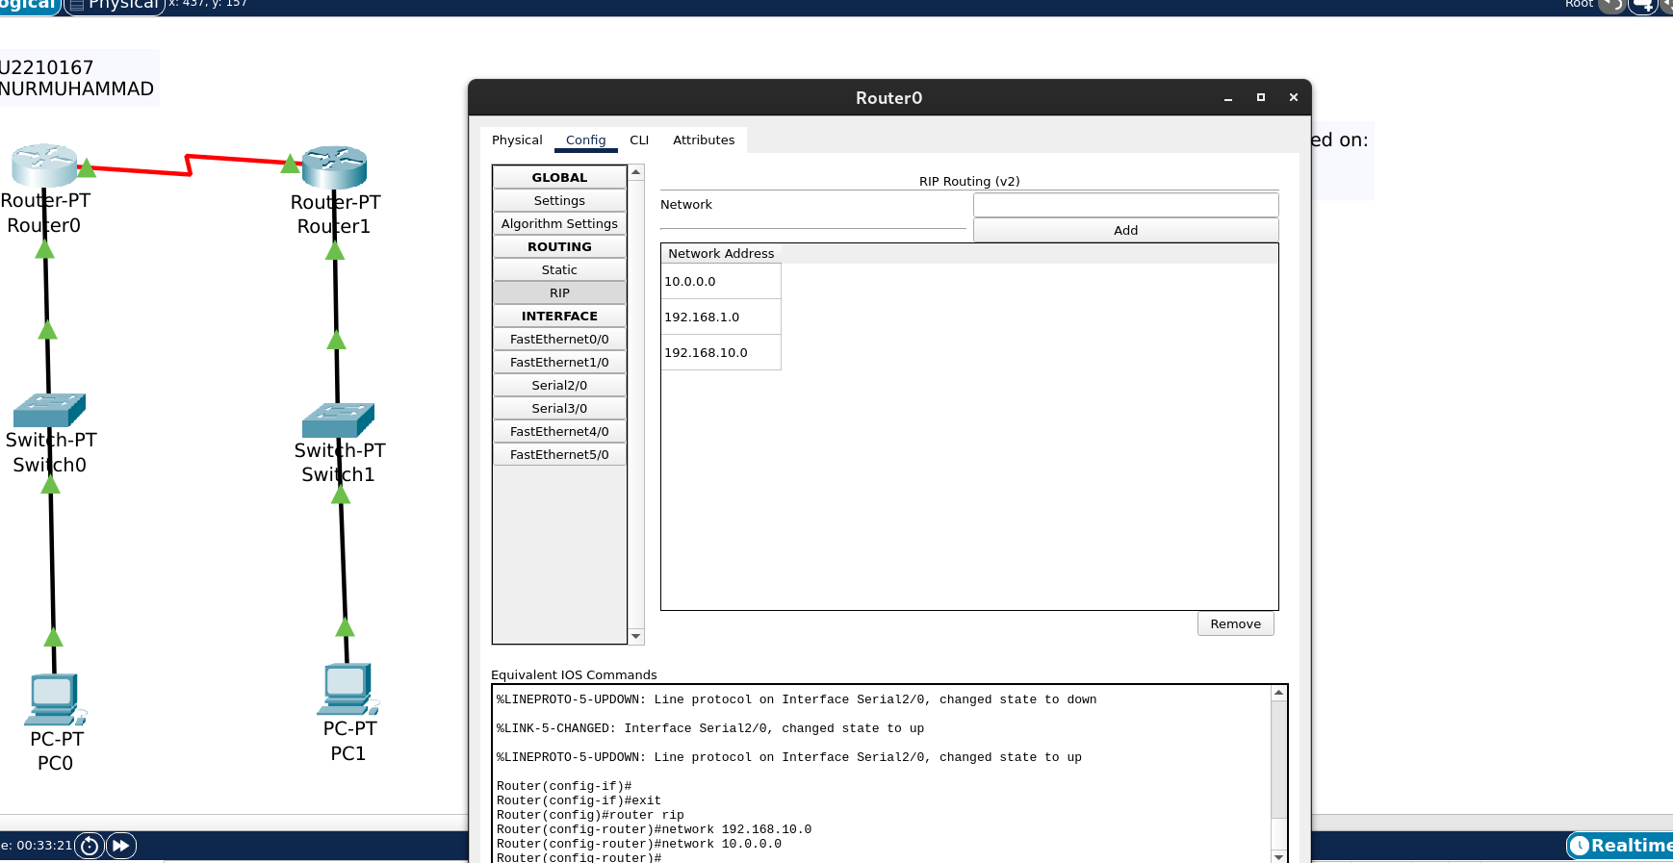

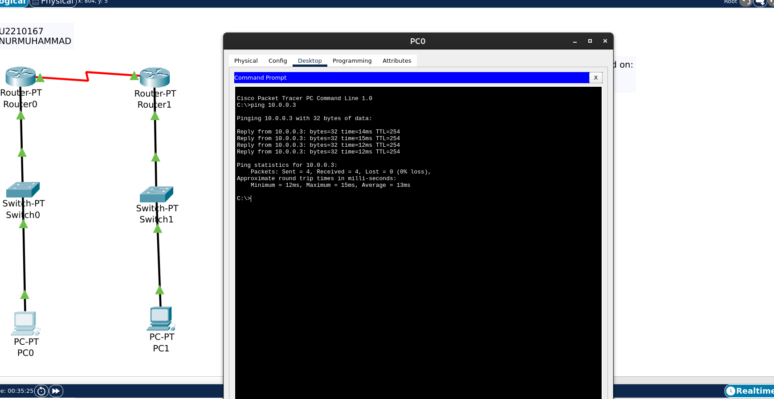

In this lab, I demonstrated the concept of Distance Vector Routing using the RIP (Routing Information Protocol) in Cisco Packet Tracer. RIP is a dynamic routing protocol that allows routers to share routing tables with directly connected neighbors and select the best path based on hop count.

To begin, I set up a simple network with three routers (Router0, Router1) connected in a linear topology. Each router was connected to a switch, and each switch was connected to a PC to simulate end devices. I used copper straight-through cables to connect routers to switches and PCs, and copper crossover cables to connect routers to each other.

I assigned IP addresses to all router interfaces and PCs to ensure they were in the correct subnet. For example, Router0’s interface FA0/0 was assigned 192.168.10.1/24, Router1’s fa0/0 was assigned 192.168.20.1/24.

Each router was configured with the appropriate network commands based on the directly connected subnets. After enabling RIP, the routers began sharing their routing tables.

To verify the configuration, I used the show ip route command to check the learned routes on each router. I also used the ping command from one PC to another across the network. All pings were successful, confirming that the routers exchanged routing information properly using RIP and were able to forward packets accordingly.

Through this lab, I understood how Distance Vector Routing works with RIP, how routers share routes with neighbors, and how routing tables are dynamically updated. This provided valuable insight into the functioning of dynamic routing protocols in real-world network environments.

**Activity 9**

Configuring VLAN and Inter Routing VLAN setup using Cisco Packet

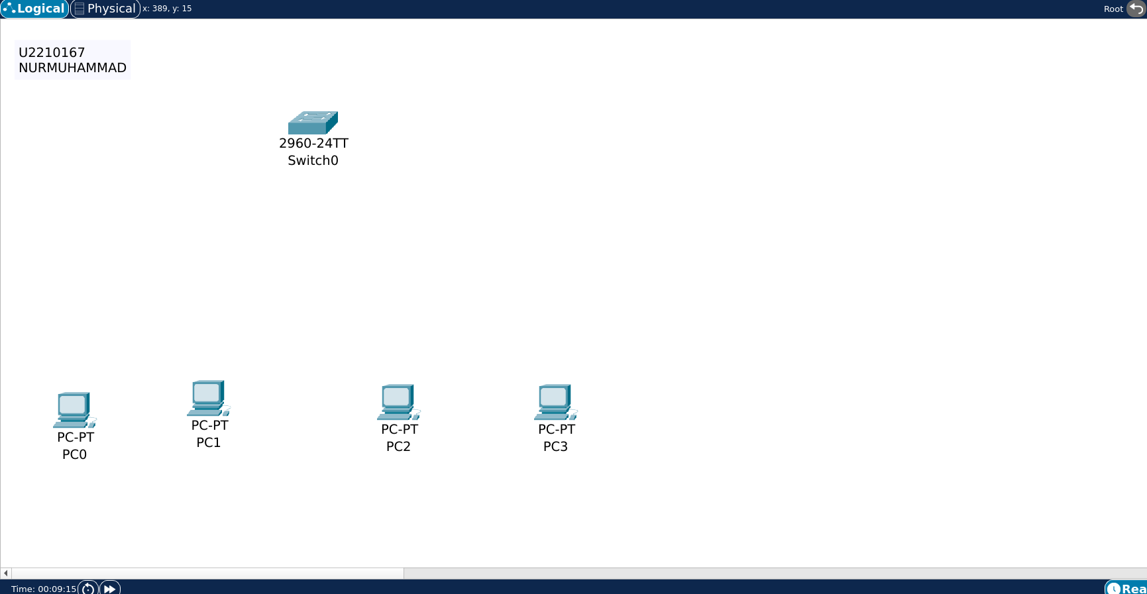

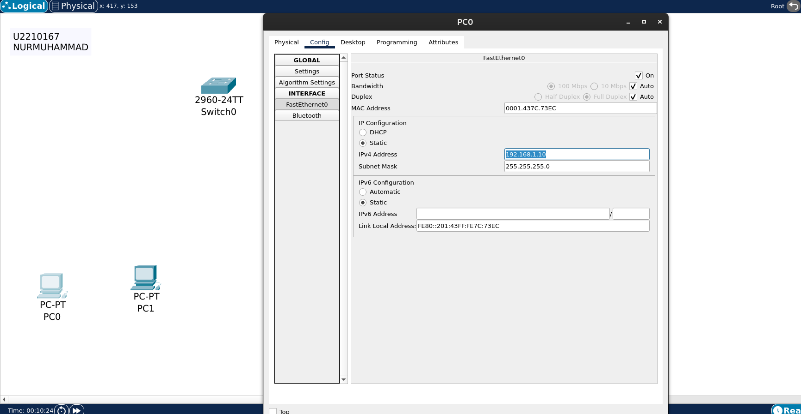

repeat for all other PC

PC0- 192.168.1.10

PC1-192.168.1.20

PC2-192.168.1.30

PC3-192.168.1.40

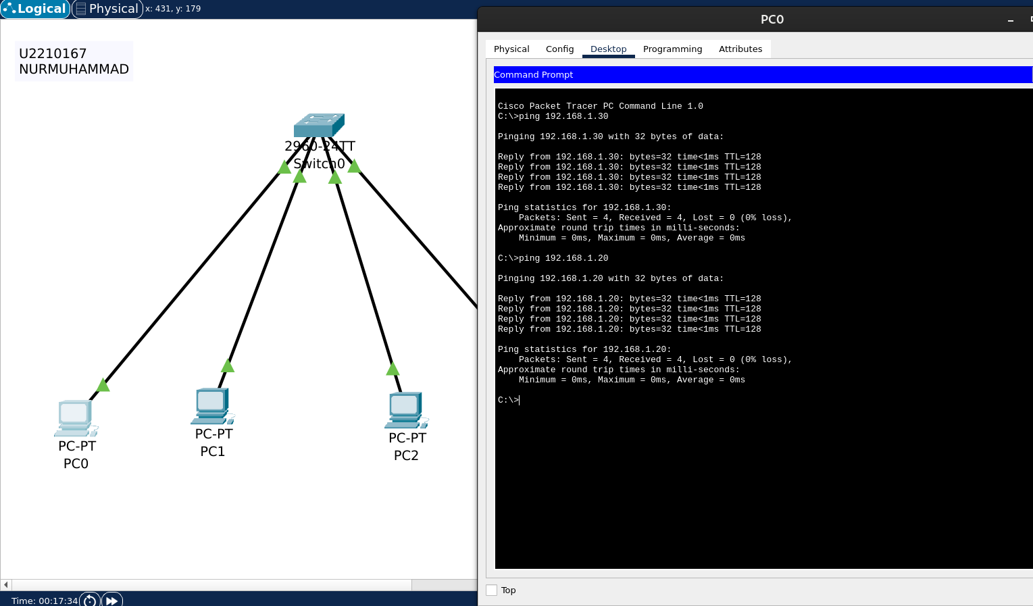

connecting vlan

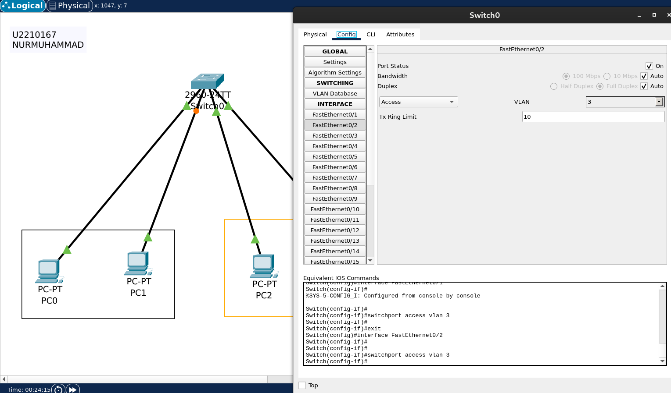

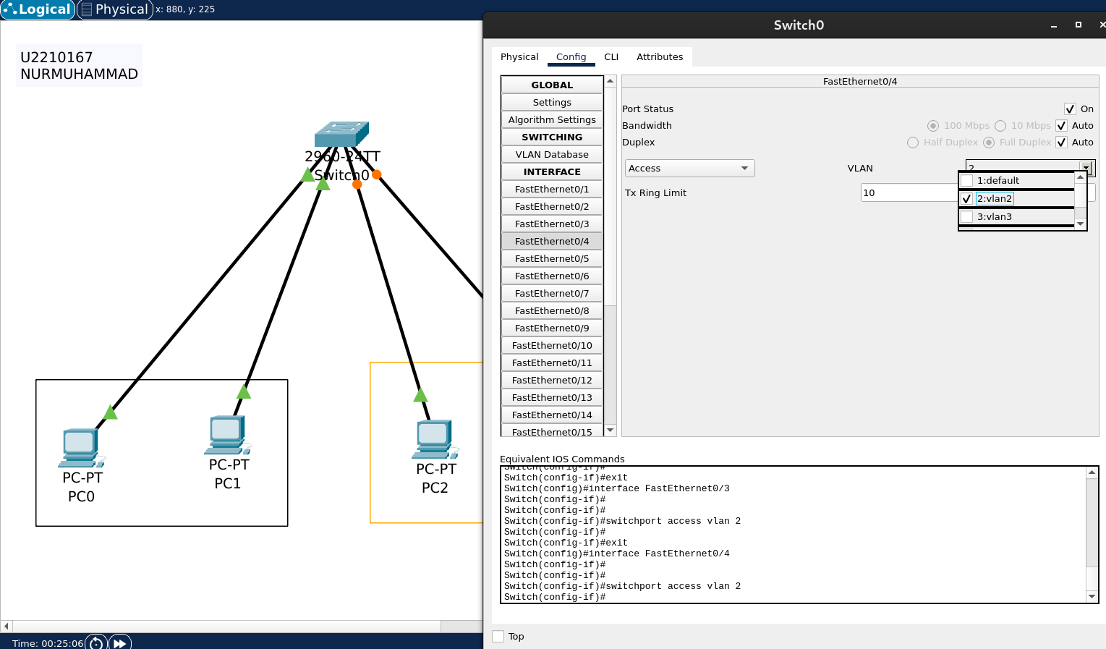\

as we can see it is not possible to connect now

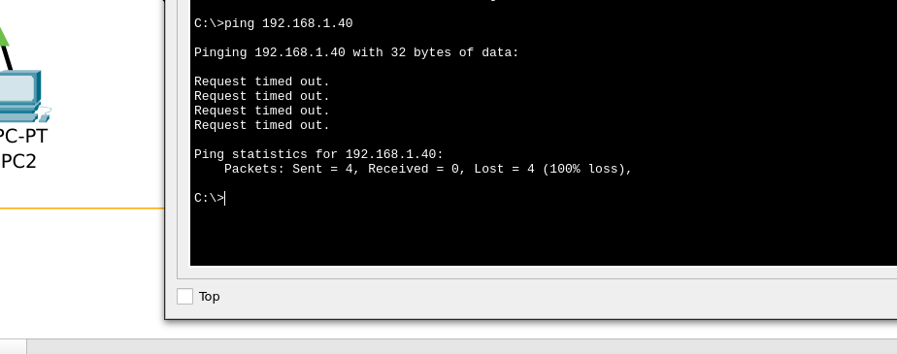

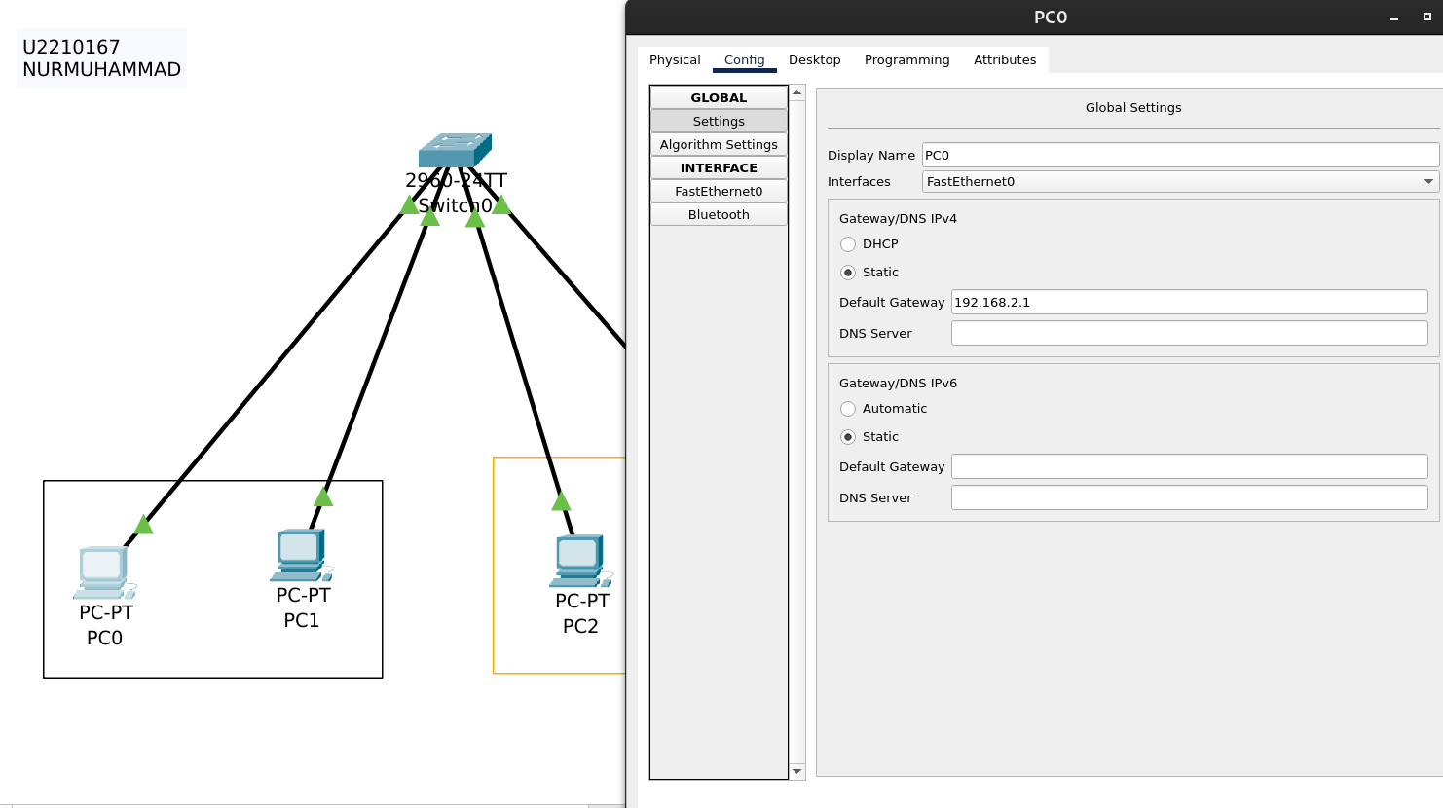

router config

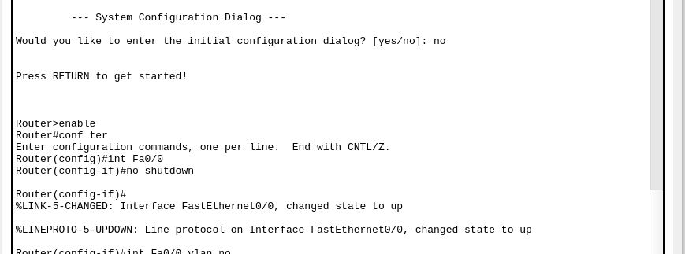

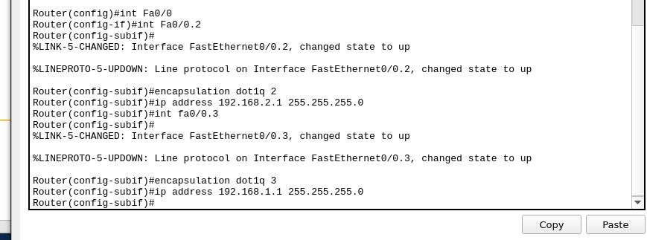

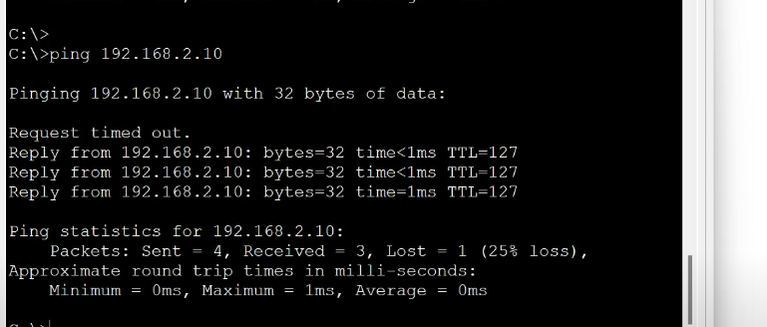

now we can see it is working

In this lab, I successfully implemented and analyzed the Routing Information Protocol (RIP) within a simulated network environment using Cisco Packet Tracer. RIP, a distance-vector routing protocol, operates by having routers periodically exchange their entire routing tables with immediate neighbors. This exchange allows routers to dynamically learn about remote networks and determine optimal paths based on hop count, with a maximum allowable hop to prevent routing loops .

**Activity 10**

A newly established two-floor building is ready to start a new office soon. You are hired to set up network to connect all IT resources of the office. Following are the guideline for network set up.

## 1. Network Requirements Analysis

Based on the provided requirements, we need to design a network that supports:

### First Floor:

* Reception desk with internet access
* Coffee shop with 2 isolated computers (no internet)
* Waiting room with wireless access for visitors

### Second Floor:

* Library with 3 interconnected computers and a shared printer (no internet)
* 2 office rooms with employee computers that have:
  + Internet access via Wi-Fi
  + Intra-company communication capabilities

## 2. Network Topology Design

We'll implement a **hierarchical star topology** with VLAN segmentation to meet the specific connectivity and isolation requirements.

### Logical Network Segments (VLANs):

|  |  |  |  |
| --- | --- | --- | --- |
| **VLAN ID** | **Name** | **Description** | **Internet Access** |
| 10 | MANAGEMENT | Network devices management | Yes (restricted) |
| 20 | RECEPTION | Reception desk computers | Yes |
| 30 | EMPLOYEE | Office workstations | Yes |
| 40 | GUEST | Visitor Wi-Fi in waiting room | Yes (limited) |
| 50 | LIBRARY | Library computers and printer | No |
| 60 | CAFETERIA | Coffee shop computers | No |

### IP Address Allocation:

|  |  |  |  |  |
| --- | --- | --- | --- | --- |
| **Network Segment** | **Subnet** | **Subnet Mask** | **Available IPs** | **Default Gateway** |
| Management | 192.168.10.0/24 | 255.255.255.0 | 192.168.10.1-254 | 192.168.10.1 |
| Reception | 192.168.20.0/24 | 255.255.255.0 | 192.168.20.1-254 | 192.168.20.1 |
| Employee | 192.168.30.0/24 | 255.255.255.0 | 192.168.30.1-254 | 192.168.30.1 |
| Guest | 192.168.40.0/24 | 255.255.255.0 | 192.168.40.1-254 | 192.168.40.1 |
| Library | 192.168.50.0/24 | 255.255.255.0 | 192.168.50.1-254 | 192.168.50.1 |
| Cafeteria | 192.168.60.0/24 | 255.255.255.0 | 192.168.60.1-254 | N/A |

## 3. Hardware Requirements

### Core Network Infrastructure:

* 1× Router (Cisco 2911 or equivalent) - Internet connectivity and inter-VLAN routing
* 2× Layer 2 Managed Switches (Cisco 2960 or equivalent) - One for each floor
* 2× Wireless Access Points - One for waiting room, one for employee Wi-Fi

### End-User Equipment:

* 1× Reception computer
* 2× Coffee shop computers (isolated)
* 6× Office computers (3 per room)
* 3× Library computers
* 1× Network printer for library
* 1× File server for library

### Cabling Requirements:

* Cat6 Ethernet cables for all wired connections (~300m total)
* 1× Fiber optic cable for inter-floor connectivity (25m)

## 5. Security Considerations

* **Firewall**: Configured on the main router to protect the internal network
* **Access Control Lists (ACLs)**: Implemented to restrict traffic between VLANs
* **Wi-Fi Security**:
  + Employee Wi-Fi: WPA2 Enterprise with 802.1X authentication
  + Guest Wi-Fi: WPA2 Personal with isolated client access
* **VLAN Isolation**: Coffee shop and library networks completely isolated from internet
* **Network Monitoring**: Implementation of SNMP for device monitoring

## 6. Future Scalability

The network design provides room for growth with:

* Additional switch ports available for expansion
* VLAN structure that can accommodate new departments
* Router capable of handling increased bandwidth needs
* Wireless infrastructure that can be expanded with additional access points

## 7. Maintenance Recommendations

* Quarterly firmware updates for all network devices
* Monthly backup of router and switch configurations
* Implementation of network monitoring solution
* Documentation of all IP addresses and network changes
* Regular security audits and vulnerability assessments

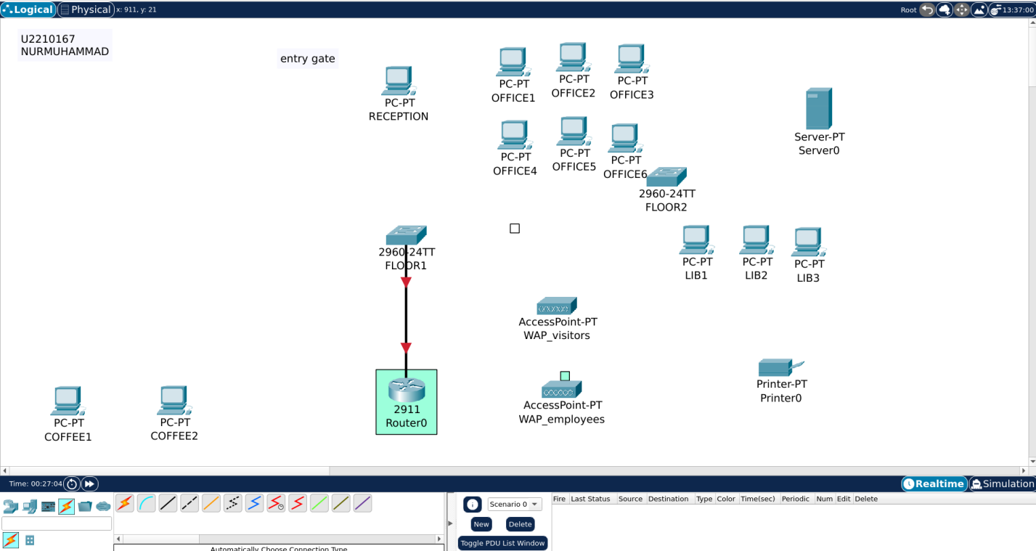

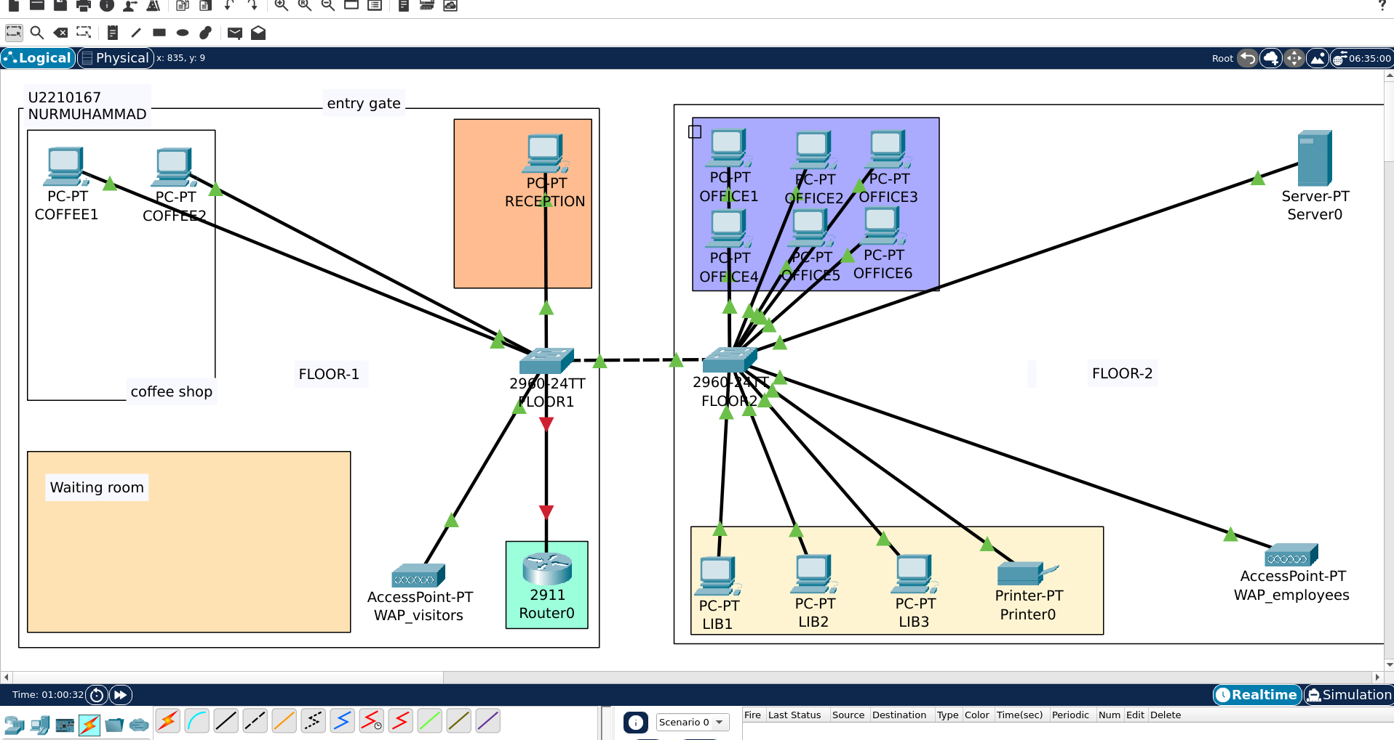

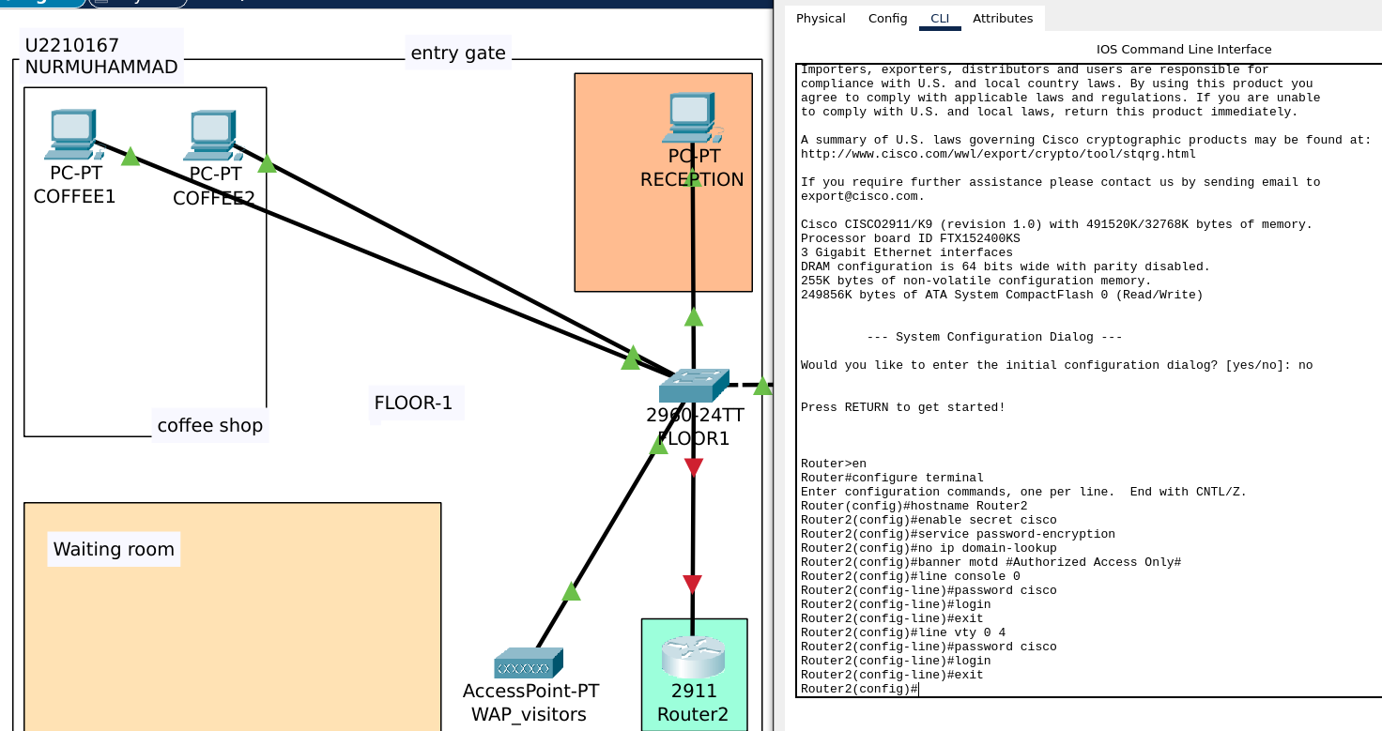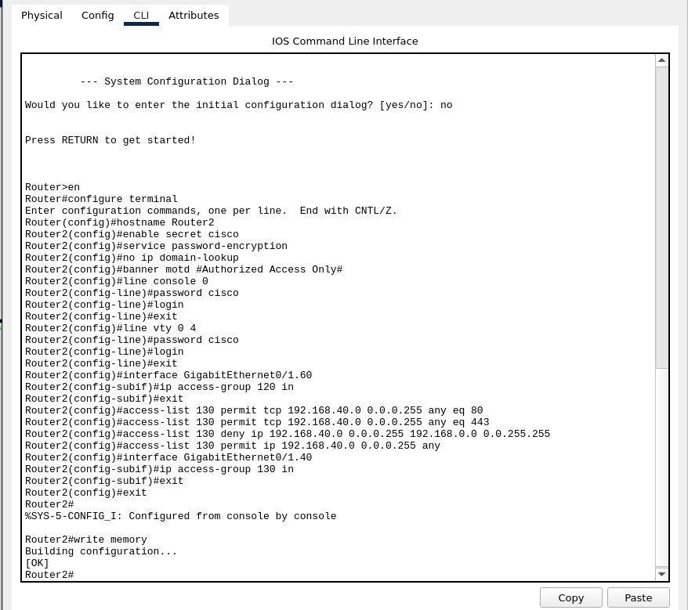

Switch floor1

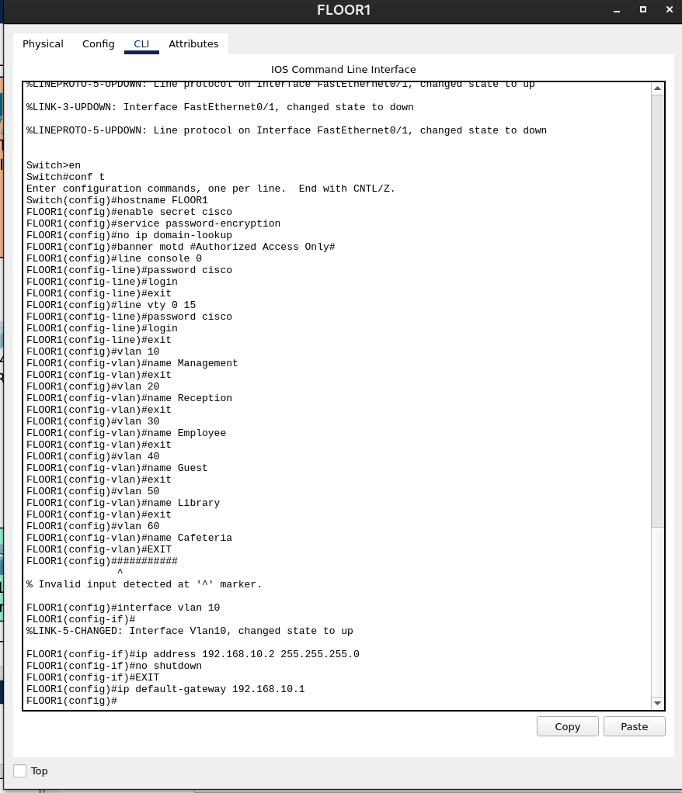

config switch at floor 1

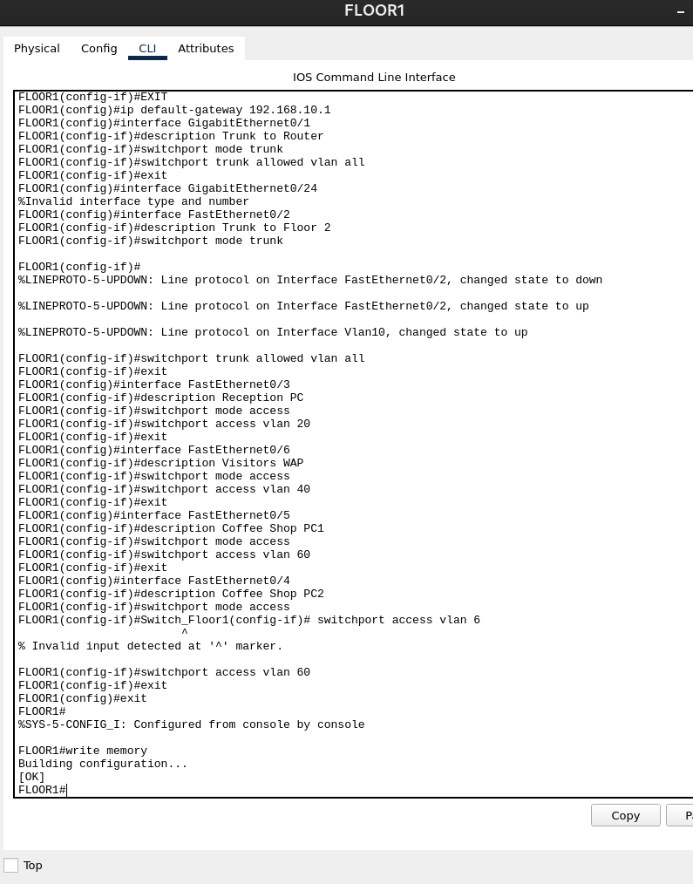

Configure Second Floor Switch

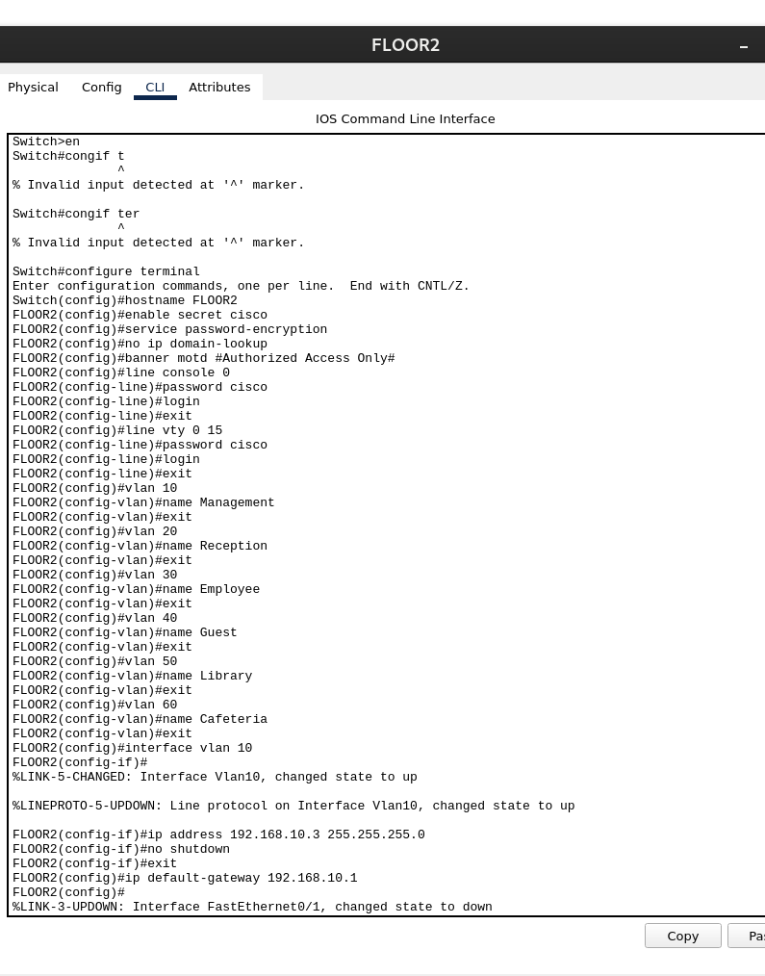

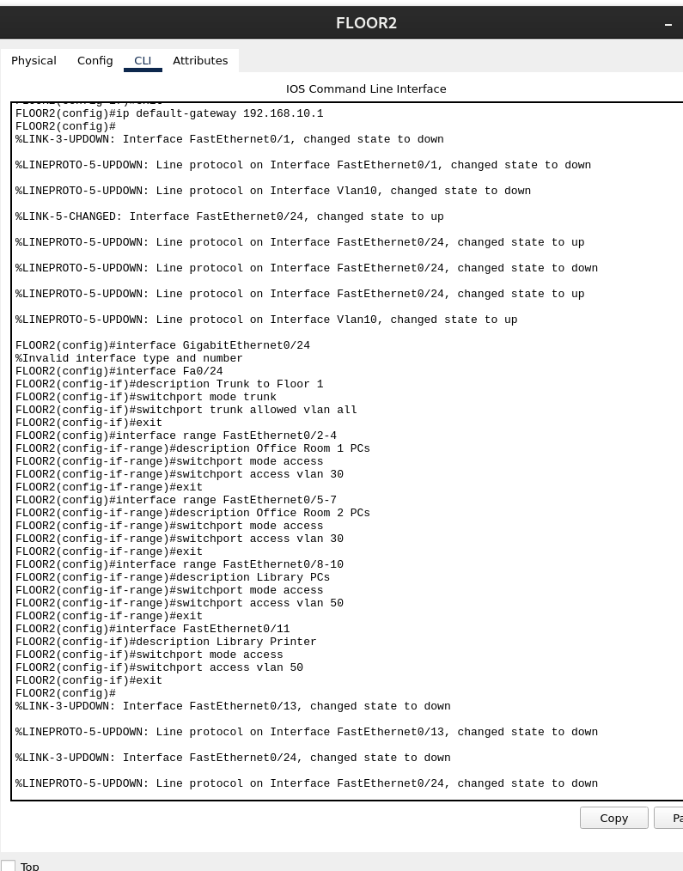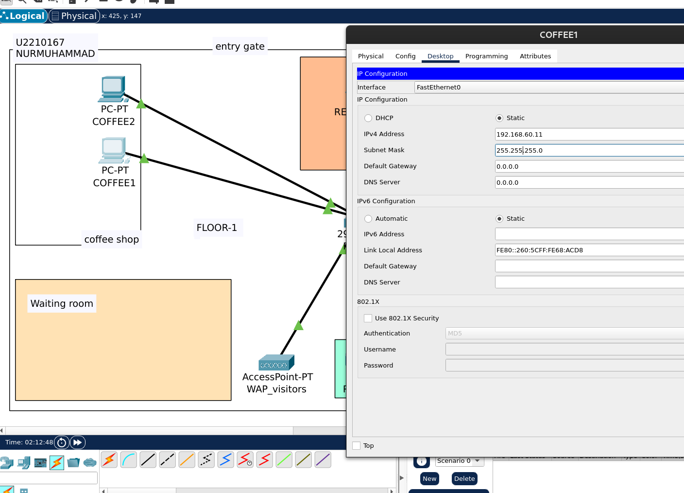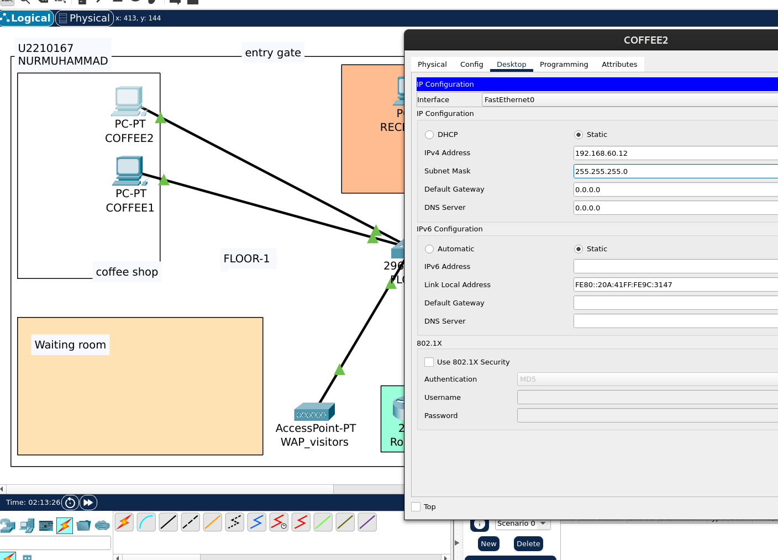

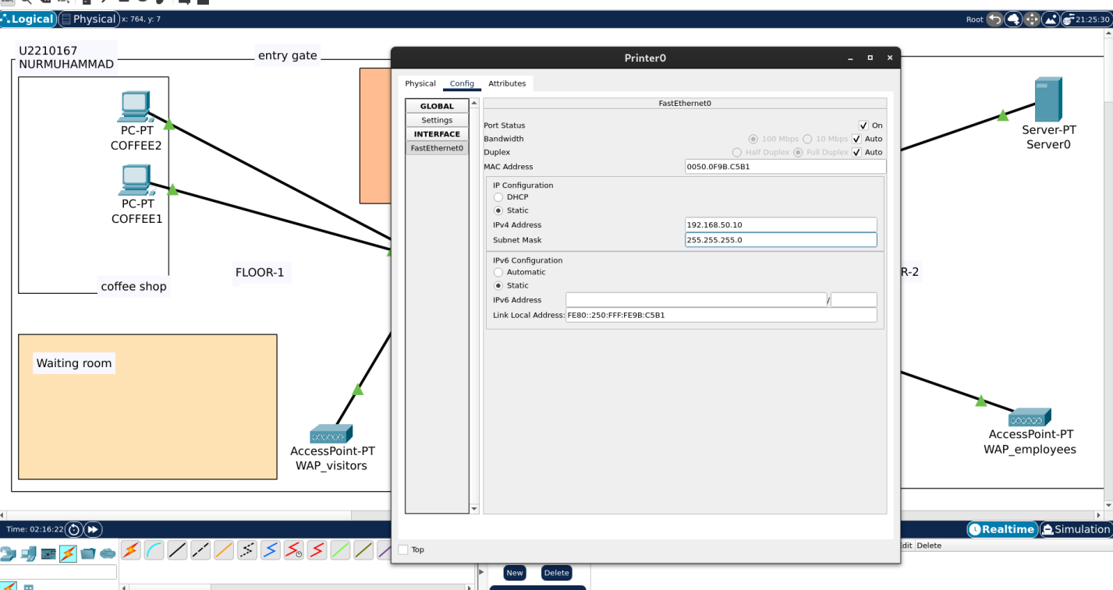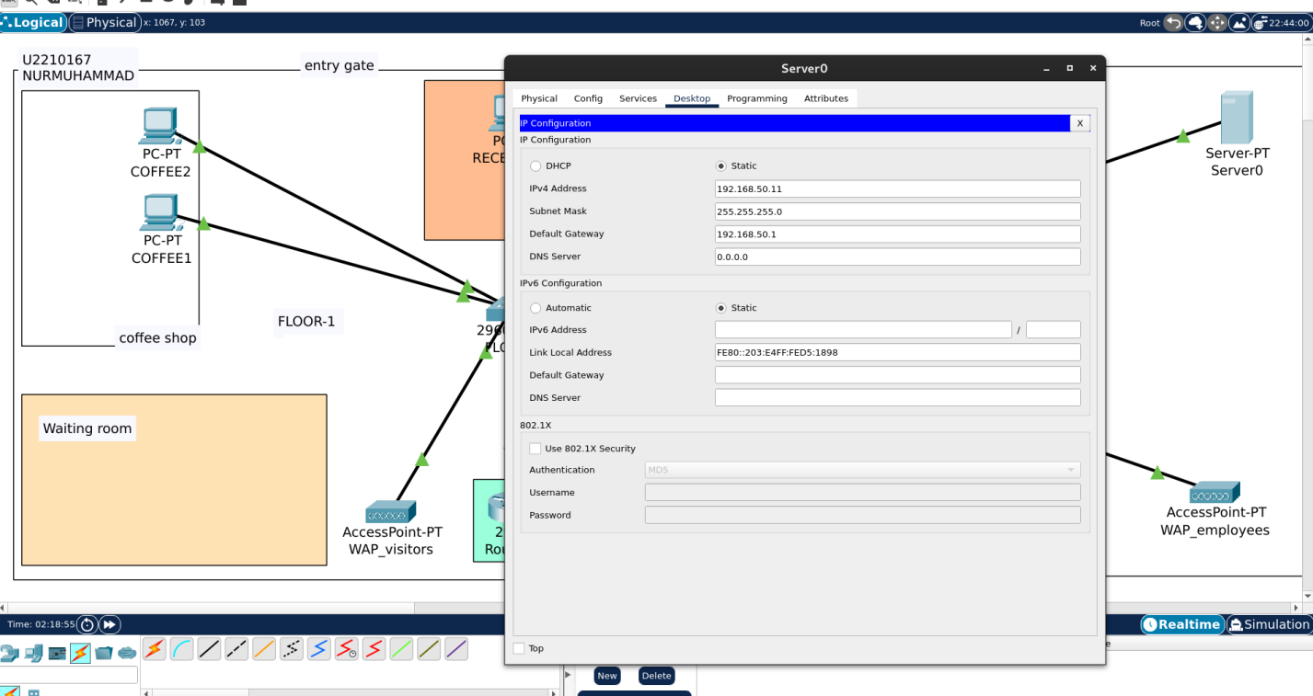

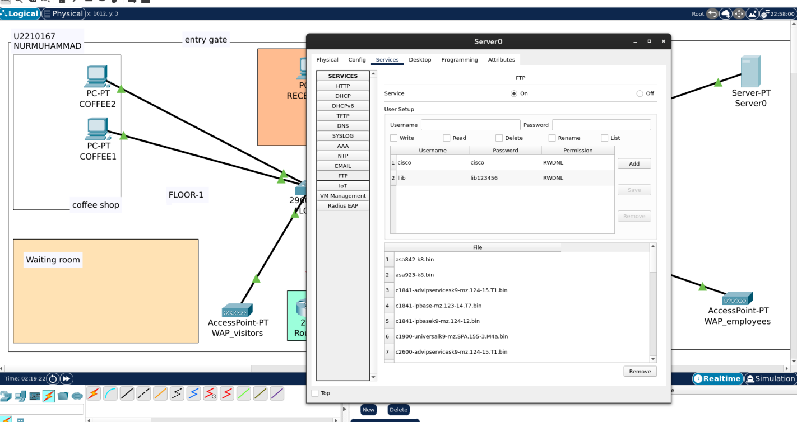

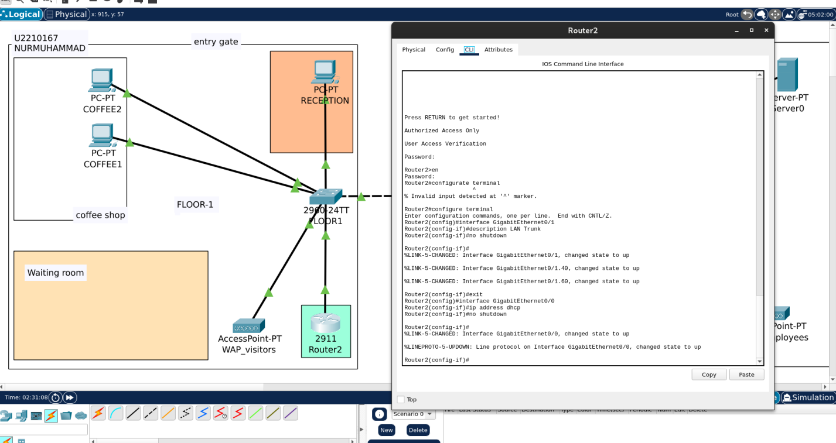

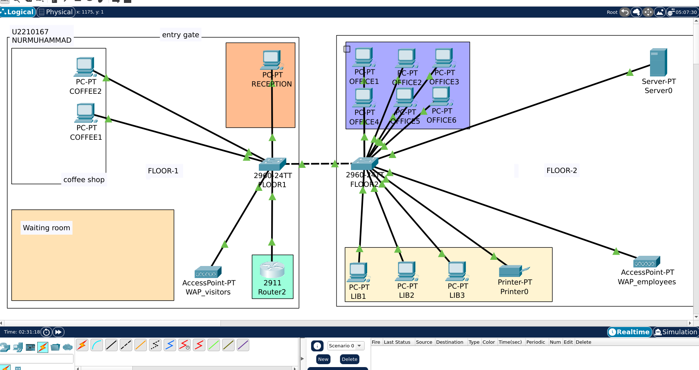

I've created a comprehensive conclusion for your network design project. The conclusion summarizes the entire implementation, highlights key accomplishments, and provides recommendations for future enhancements.Here are the key points from the conclusion:

* The project successfully implemented a hierarchical star topology with strategic VLAN segmentation for the two-floor office building
* All specific requirements were met, including:
  + Reception desk internet access
  + Isolated computers in the coffee shop
  + Visitor wireless access in the waiting room
  + Library computers with file sharing and printing capabilities
  + Employee workstations with both internet and intra-company communication

The network design prioritized:

* **Security** through VLAN segregation, access control lists, and secure wireless configurations
* **Scalability** with room for additional devices and network segments
* **Performance** using gigabit connections between core infrastructure

The implementation represents a cost-effective solution at approximately $7,150, providing an enterprise-grade foundation that can support future business growth.

For future enhancements, I recommended implementing a network monitoring system, adding a redundant internet connection, enhancing power backup solutions, implementing 802.1X authentication, and configuring QoS policies.

This project demonstrated the importance of thorough requirements gathering, logical VLAN design, comprehensive documentation, and proper testing to validate security configurations.

Equipment Costs

|  |  |  |  |  |
| --- | --- | --- | --- | --- |
| **Item** | **Quantity** | **Unit Price (USD)** | **Total (USD)** | **Price Source** |
| Cisco 2911 Router | 1 | $1,200 - $2,000 | $1,200 - $2,000 | [Amazon](https://www.amazon.com/Cisco-2911-Router-CISCO2911-K9/dp/B002KVLF8C) / [CDW](https://www.cdw.com/product/cisco-2911-router/2169389) |
| Cisco 2960-24TT Switch | 2 | $800 - $1,200 | $1,600 - $2,400 | [Amazon](https://www.amazon.com/Cisco-WS-C2960-24TT-L-Catalyst-24-Port-Switch/dp/B000NU0T2W) / [eBay](https://www.ebay.com/itm/155343271494) |
| Wireless Access Point | 2 | $150 - $500 | $300 - $1,000 | [Amazon - Cisco Business WAP](https://www.amazon.com/Cisco-Business-Wireless-Access-Point/dp/B087QXT8F5/) / [B&H - Ubiquiti WAP](https://www.bhphotovideo.com/c/product/1205631-REG/ubiquiti_networks_uap_ac_lite_unifi_ac_lite_access.html) |
| Desktop Computers | 12 | $500 - $1,000 | $6,000 - $12,000 | [Dell OptiPlex 3000](https://www.dell.com/en-us/shop/desktops-all-in-one-pcs/optiplex-3000-small-form-factor/spd/optiplex-3000-small-desktop/s014o3000sffus) / [HP ProDesk](https://www.hp.com/us-en/shop/pdp/hp-prodesk-600-g6-small-form-factor-pc-customizable-285r0av-mb) |
| Network Printer | 1 | $300 - $700 | $300 - $700 | [HP LaserJet Pro](https://www.amazon.com/HP-LaserJet-M404n-Monochrome-W1A52A/dp/B07Q44DQLZ/) / [Brother Network Printer](https://www.staples.com/Brother-HL-L6200DW-Monochrome-Laser-Single-Function-Printer/product_2121694) |
| Server | 1 | $2,500 - $5,000 | $2,500 - $5,000 | [Dell PowerEdge T340](https://www.dell.com/en-us/shop/servers-storage-and-networking/poweredge-t340-tower-server/spd/poweredge-t340/pe_t340_tm_vi_vp) / [HPE ProLiant ML350](https://www.insight.com/en_US/shop/product/P21788-001/HPE/P21788-001/HPE-ProLiant-ML350-Gen10--tower--Xeon-Silver-4210R-21-GHz--16-GB--no-HDD/) |
| Cabling (Cat6) | ~500ft | $0.30 - $0.50/ft | $150 - $250 | [Monoprice Cat6 Cable](https://www.monoprice.com/product?p_id=13674) / [Cable Matters Bulk Cable](https://www.amazon.com/Cable-Matters-Snagless-Ethernet-Copper/dp/B00HEM508K/) |
| Fiber Cable | ~50ft | $1 - $3/ft | $50 - $150 | [FS.com Fiber Cable](https://www.fs.com/products/40180.html) / [Fiber Optic Cable on Amazon](https://www.amazon.com/FiberCablesDirect-Multimode-Duplex-50-125-10Gb/dp/B07KYHW2LV/) |
| Rack and Cabinet | 1 | $300 - $800 | $300 - $800 | [StarTech Open Frame Rack](https://www.amazon.com/StarTech-com-Open-Frame-Server-Rack/dp/B00P1RJ9LS/) / [Tripp Lite Wall Mount Rack](https://www.cdw.com/product/tripp-lite-12u-wall-mount-rack-enclosure-server-cabinet-hinged-w-door-and-s/4010370) |

**Equipment Subtotal: $12,400 - $24,300**

## Installation & Setup Services

|  |  |  |
| --- | --- | --- |
| **Service** | **Cost (USD)** | **Source** |
| Network Design & Planning | $1,500 - $3,000 | [CDW Consulting Services](https://www.cdw.com/content/cdw/en/services/consulting-services.html) / [Insight Planning Services](https://www.insight.com/en_US/what-we-do/services/consulting.html) |
| Physical Installation | $2,000 - $4,000 | [Field Nation - Labor Costs](https://fieldnation.com/insights/how-much-does-it-cost-to-install-a-network) / [Best Buy Business Services](https://www.bestbuy.com/site/services/geek-squad-business/pcmcat748300502884.c?id=pcmcat748300502884) |
| Network Configuration | $1,000 - $2,500 | [IT Service Provider Reviews - Hourly Rates](https://www.gartner.com/reviews/market/it-service-providers) / [Thumbtack Network Setup](https://www.thumbtack.com/p/network-setup-cost) |
| Testing & Quality Assurance | $500 - $1,500 | [Network Testing Services Market Rates](https://www.comptia.org/content/research/it-industry-trends-analysis) / [CXtec Infrastructure Services](https://www.cxtec.com/services/infrastructure-services/) |

## Annual Maintenance & Support

|  |  |  |
| --- | --- | --- |
| **Service** | **Annual Cost (USD)** | **Source** |
| ISP Internet Service | $1,200 - $3,600 | [Comcast Business Internet](https://business.comcast.com/internet) / [Verizon Business Internet](https://www.verizon.com/business/products/business-internet/) |
| Hardware Maintenance Contract | $1,500 - $3,000 | [Cisco SMARTnet Pricing](https://www.provantage.com/cisco-systems-con-snt-c2911~7CSCO0WK.htm) / [Dell ProSupport](https://www.dell.com/en-us/dt/services/support-services/prosupport-enterprise-suite.htm) |
| Software Licenses & Updates | $800 - $2,000 | [Microsoft 365 Business](https://www.microsoft.com/en-us/microsoft-365/business/compare-all-microsoft-365-business-products) / [Cisco Software Subscriptions](https://www.cisco.com/c/en/us/products/software/buying-guide.html) |
| IT Support (part-time/outsourced) | $10,000 - $20,000 | [Managed IT Services Average Costs](https://www.connectwise.com/blog/managed-services/how-much-does-managed-it-services-cost) / [IT Support Pricing Models](https://www.itproportal.com/features/it-support-pricing-models-explained/) |
| Backup Solutions | $500 - $1,200 | [Backblaze Business](https://www.backblaze.com/cloud-backup/business-backup-pricing) / [Carbonite Business Backup](https://www.carbonite.com/backup-software/buy-carbonite-safe/business) |

**Annual Maintenance Subtotal: $14,000 - $29,800**

## Total Estimated Costs

* **One-time Equipment Costs: $12,400 - $24,300**
* **One-time Installation & Setup: $5,000 - $11,000**
* **Annual Maintenance & Support: $14,000 - $29,800**

**Total First Year Cost: $31,400 - $65,100**